Predicting Home Price in King County, WA

The object of this project was to determine the price of a home in King County, WA with a given set of criteria employing commonly used data mining techniques. The data used here in predicting home price is the House Sales in King County, USA dataset currently *housed* on Kaggle.com at <https://www.kaggle.com/gabriellima/house-sales-in-king-county-usa>. The observations in the dataset reflect the sales of homes for King County during May 2014-May 2015, and include the date and sale price of a home and property features, such as the number of bedrooms, bathrooms, the size of the lot and living space, the condition of the home, year built, and the property location.

Given the *properties* of the homes included in the dataset, the criteria used to predict a home price in this project were the following:

1. 4 bedroom
2. 3 bathroom
3. 4,000 sq/ft living
4. 5,000 sq/ft lot
5. Good condition (5+)
6. Good grade (7+)
7. Newer construction (2004+)

As the problem here involved predicting a single continuous-type value, popular regression methods linear regression and random forests were *constructed*. Four linear models and two random forest models were built, and ultimately, the initial random forest model performed the best and was selected as the primary model used in prediction. Through building the models, other criteria not included in the given set were deemed to be important in the performance of the prediction models. The models performed best if these features were also being used to predict the price of a home.

Included below is a markdown version of the R code and resulting plots and predictions. (Added text is highlighted for easier reading.)

## Load libraries, set seed, set data file

library(corrgram)

## Registered S3 methods overwritten by 'ggplot2':  
## method from   
## [.quosures rlang  
## c.quosures rlang  
## print.quosures rlang

## Registered S3 method overwritten by 'seriation':  
## method from   
## reorder.hclust gclus

library(randomForest)

## randomForest 4.6-14

## Type rfNews() to see new features/changes/bug fixes.

library(GGally)

## Loading required package: ggplot2

##   
## Attaching package: 'ggplot2'

## The following object is masked from 'package:randomForest':  
##   
## margin

## Registered S3 method overwritten by 'GGally':  
## method from   
## +.gg ggplot2

library(caret)

## Loading required package: lattice

##   
## Attaching package: 'lattice'

## The following object is masked from 'package:corrgram':  
##   
## panel.fill

library(tidyverse)

## ── Attaching packages ──────────────────────────────────────────────────────────────────────────────── tidyverse 1.2.1 ──

## ✔ tibble 2.1.1 ✔ purrr 0.3.2   
## ✔ tidyr 0.8.3 ✔ dplyr 0.8.0.1  
## ✔ readr 1.3.1 ✔ stringr 1.4.0   
## ✔ tibble 2.1.1 ✔ forcats 0.4.0

## ── Conflicts ─────────────────────────────────────────────────────────────────────────────────── tidyverse_conflicts() ──  
## ✖ dplyr::combine() masks randomForest::combine()  
## ✖ dplyr::filter() masks stats::filter()  
## ✖ dplyr::lag() masks stats::lag()  
## ✖ purrr::lift() masks caret::lift()  
## ✖ ggplot2::margin() masks randomForest::margin()

library(ggplot2)  
library(reshape)

##   
## Attaching package: 'reshape'

## The following object is masked from 'package:dplyr':  
##   
## rename

## The following objects are masked from 'package:tidyr':  
##   
## expand, smiths

set.seed(1234)

setwd("/Users/cocoapuffs/Desktop/UW Data Analytics/Course 3/Final Project")  
  
file = 'kc_house_data.csv'

## Load dataset & remove ID

house_raw = read_csv(file)

## Parsed with column specification:  
## cols(  
## .default = col_double(),  
## id = col_character(),  
## date = col_datetime(format = "")  
## )

## See spec(...) for full column specifications.

house_raw$id <- NULL  
  
summary(house_raw)

## date price bedrooms   
## Min. :2014-05-02 00:00:00 Min. : 75000 Min. : 0.000   
## 1st Qu.:2014-07-22 00:00:00 1st Qu.: 321950 1st Qu.: 3.000   
## Median :2014-10-16 00:00:00 Median : 450000 Median : 3.000   
## Mean :2014-10-29 04:38:01 Mean : 540088 Mean : 3.371   
## 3rd Qu.:2015-02-17 00:00:00 3rd Qu.: 645000 3rd Qu.: 4.000   
## Max. :2015-05-27 00:00:00 Max. :7700000 Max. :33.000   
## bathrooms sqft_living sqft_lot floors   
## Min. :0.000 Min. : 290 Min. : 520 Min. :1.000   
## 1st Qu.:1.750 1st Qu.: 1427 1st Qu.: 5040 1st Qu.:1.000   
## Median :2.250 Median : 1910 Median : 7618 Median :1.500   
## Mean :2.115 Mean : 2080 Mean : 15107 Mean :1.494   
## 3rd Qu.:2.500 3rd Qu.: 2550 3rd Qu.: 10688 3rd Qu.:2.000   
## Max. :8.000 Max. :13540 Max. :1651359 Max. :3.500   
## waterfront view condition grade   
## Min. :0.000000 Min. :0.0000 Min. :1.000 Min. : 1.000   
## 1st Qu.:0.000000 1st Qu.:0.0000 1st Qu.:3.000 1st Qu.: 7.000   
## Median :0.000000 Median :0.0000 Median :3.000 Median : 7.000   
## Mean :0.007542 Mean :0.2343 Mean :3.409 Mean : 7.657   
## 3rd Qu.:0.000000 3rd Qu.:0.0000 3rd Qu.:4.000 3rd Qu.: 8.000   
## Max. :1.000000 Max. :4.0000 Max. :5.000 Max. :13.000   
## sqft_above sqft_basement yr_built yr_renovated   
## Min. : 290 Min. : 0.0 Min. :1900 Min. : 0.0   
## 1st Qu.:1190 1st Qu.: 0.0 1st Qu.:1951 1st Qu.: 0.0   
## Median :1560 Median : 0.0 Median :1975 Median : 0.0   
## Mean :1788 Mean : 291.5 Mean :1971 Mean : 84.4   
## 3rd Qu.:2210 3rd Qu.: 560.0 3rd Qu.:1997 3rd Qu.: 0.0   
## Max. :9410 Max. :4820.0 Max. :2015 Max. :2015.0   
## zipcode lat long sqft_living15   
## Min. :98001 Min. :47.16 Min. :-122.5 Min. : 399   
## 1st Qu.:98033 1st Qu.:47.47 1st Qu.:-122.3 1st Qu.:1490   
## Median :98065 Median :47.57 Median :-122.2 Median :1840   
## Mean :98078 Mean :47.56 Mean :-122.2 Mean :1987   
## 3rd Qu.:98118 3rd Qu.:47.68 3rd Qu.:-122.1 3rd Qu.:2360   
## Max. :98199 Max. :47.78 Max. :-121.3 Max. :6210   
## sqft_lot15   
## Min. : 651   
## 1st Qu.: 5100   
## Median : 7620   
## Mean : 12768   
## 3rd Qu.: 10083   
## Max. :871200

glimpse(house_raw)

## Observations: 21,613  
## Variables: 20  
## $ date <dttm> 2014-10-13, 2014-12-09, 2015-02-25, 2014-12-09, 2…  
## $ price <dbl> 221900, 538000, 180000, 604000, 510000, 1225000, 2…  
## $ bedrooms <dbl> 3, 3, 2, 4, 3, 4, 3, 3, 3, 3, 3, 2, 3, 3, 5, 4, 3,…  
## $ bathrooms <dbl> 1.00, 2.25, 1.00, 3.00, 2.00, 4.50, 2.25, 1.50, 1.…  
## $ sqft_living <dbl> 1180, 2570, 770, 1960, 1680, 5420, 1715, 1060, 178…  
## $ sqft_lot <dbl> 5650, 7242, 10000, 5000, 8080, 101930, 6819, 9711,…  
## $ floors <dbl> 1.0, 2.0, 1.0, 1.0, 1.0, 1.0, 2.0, 1.0, 1.0, 2.0, …  
## $ waterfront <dbl> 0, 0, 0, 0, 0, 0, 0, 0, 0, 0, 0, 0, 0, 0, 0, 0, 0,…  
## $ view <dbl> 0, 0, 0, 0, 0, 0, 0, 0, 0, 0, 0, 0, 0, 0, 0, 3, 0,…  
## $ condition <dbl> 3, 3, 3, 5, 3, 3, 3, 3, 3, 3, 3, 4, 4, 4, 3, 3, 3,…  
## $ grade <dbl> 7, 7, 6, 7, 8, 11, 7, 7, 7, 7, 8, 7, 7, 7, 7, 9, 7…  
## $ sqft_above <dbl> 1180, 2170, 770, 1050, 1680, 3890, 1715, 1060, 105…  
## $ sqft_basement <dbl> 0, 400, 0, 910, 0, 1530, 0, 0, 730, 0, 1700, 300, …  
## $ yr_built <dbl> 1955, 1951, 1933, 1965, 1987, 2001, 1995, 1963, 19…  
## $ yr_renovated <dbl> 0, 1991, 0, 0, 0, 0, 0, 0, 0, 0, 0, 0, 0, 0, 0, 0,…  
## $ zipcode <dbl> 98178, 98125, 98028, 98136, 98074, 98053, 98003, 9…  
## $ lat <dbl> 47.5112, 47.7210, 47.7379, 47.5208, 47.6168, 47.65…  
## $ long <dbl> -122.257, -122.319, -122.233, -122.393, -122.045, …  
## $ sqft_living15 <dbl> 1340, 1690, 2720, 1360, 1800, 4760, 2238, 1650, 17…  
## $ sqft_lot15 <dbl> 5650, 7639, 8062, 5000, 7503, 101930, 6819, 9711, …

## Data exploration through ggpairs and corr plots of the variables

Here the distribution of the feature variables were examined along with their relationship to price and other variables. Several of these, including the predicted variable price, were heavily skewed right. Others, such as waterfront and view, contained mostly zeros as most of the homes represented in the observations were not along the waterfront and did not include a (desirable) view from the property.

ggpairs(house_raw[,c(3:6,2)])

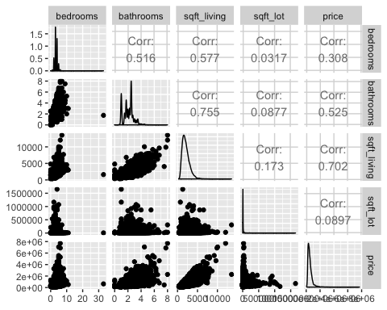

ggpairs(house_raw[,c(7:11,2)])

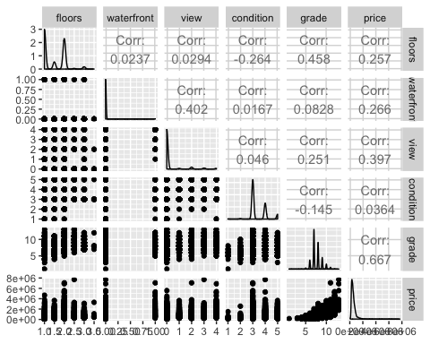

ggpairs(house_raw[,c(12:15,2)])

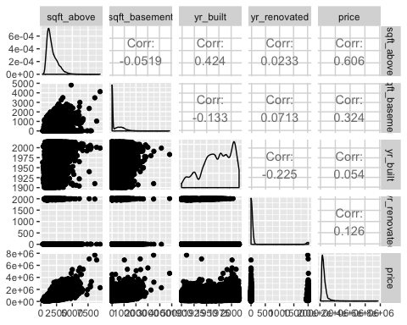

ggpairs(house_raw[,c(16:20,2)])

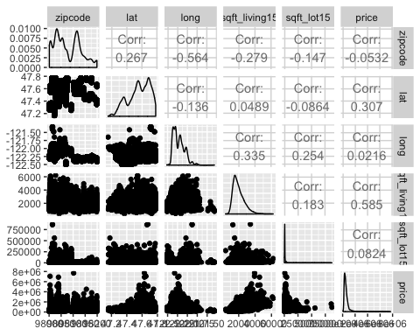

library(corrplot)

## corrplot 0.84 loaded

corrMatrix <- cor(house_raw[,c(2:20)])  
head(round(corrMatrix,2))

## price bedrooms bathrooms sqft_living sqft_lot floors  
## price 1.00 0.31 0.53 0.70 0.09 0.26  
## bedrooms 0.31 1.00 0.52 0.58 0.03 0.18  
## bathrooms 0.53 0.52 1.00 0.75 0.09 0.50  
## sqft_living 0.70 0.58 0.75 1.00 0.17 0.35  
## sqft_lot 0.09 0.03 0.09 0.17 1.00 -0.01  
## floors 0.26 0.18 0.50 0.35 -0.01 1.00  
## waterfront view condition grade sqft_above sqft_basement  
## price 0.27 0.40 0.04 0.67 0.61 0.32  
## bedrooms -0.01 0.08 0.03 0.36 0.48 0.30  
## bathrooms 0.06 0.19 -0.12 0.66 0.69 0.28  
## sqft_living 0.10 0.28 -0.06 0.76 0.88 0.44  
## sqft_lot 0.02 0.07 -0.01 0.11 0.18 0.02  
## floors 0.02 0.03 -0.26 0.46 0.52 -0.25  
## yr_built yr_renovated zipcode lat long sqft_living15  
## price 0.05 0.13 -0.05 0.31 0.02 0.59  
## bedrooms 0.15 0.02 -0.15 -0.01 0.13 0.39  
## bathrooms 0.51 0.05 -0.20 0.02 0.22 0.57  
## sqft_living 0.32 0.06 -0.20 0.05 0.24 0.76  
## sqft_lot 0.05 0.01 -0.13 -0.09 0.23 0.14  
## floors 0.49 0.01 -0.06 0.05 0.13 0.28  
## sqft_lot15  
## price 0.08  
## bedrooms 0.03  
## bathrooms 0.09  
## sqft_living 0.18  
## sqft_lot 0.72  
## floors -0.01

title <- "Correlation Plot of Variables to Price"  
corrplot(corrMatrix, method="circle", title=title, mar=c(0,0,.5,0))

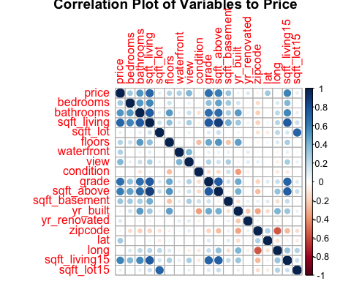

## Evaluating variable correlation

cor_level <- .7  
correlationMatrix <- cor(house_raw[,c(2:20)])  
cor_melt <- arrange(melt(correlationMatrix), desc(value), X2)  
  
View(cor_melt)  
  
dplyr::filter(cor_melt, row_number() %% 2 == 1 & value != 1.0, value > cor_level)

## X1 X2 value  
## 1 sqft_above sqft_living 0.8765966  
## 2 grade sqft_living 0.7627045  
## 3 sqft_living sqft_living15 0.7564203  
## 4 grade sqft_above 0.7559229  
## 5 bathrooms sqft_living 0.7546653  
## 6 sqft_above sqft_living15 0.7318703  
## 7 sqft_lot sqft_lot15 0.7185568  
## 8 grade sqft_living15 0.7132021  
## 9 price sqft_living 0.7020351

cor_level <- .5  
dplyr::filter(cor_melt, row_number() %% 2 == 1 & value != 1.0, X2 == 'price', value > cor_level)

## X1 X2 value  
## 1 grade price 0.6674343  
## 2 bathrooms price 0.5251375

### Removing variables that did not contribute to a good model

As a result of the information gleaned in the correlation analyses and plots, sqft_living15, sqft_lot15, and sqft_above were removed as they were colinear to sqft_living. Sqft_basement and waterfront were also removed as there were few observations(houses) that were on the waterfront or had basements. Zipcode was also not included after this point as location was also being represented by latitude and longitude variables. Other variables were seen to be correlated with each other, but were included in the given criteria, so these were maintained.

house <- house_raw %>% select(-sqft_living15, -sqft_lot15, -sqft_above, -waterfront, -zipcode, -sqft_basement)  
  
glimpse(house)

## Observations: 21,613  
## Variables: 14  
## $ date <dttm> 2014-10-13, 2014-12-09, 2015-02-25, 2014-12-09, 20…  
## $ price <dbl> 221900, 538000, 180000, 604000, 510000, 1225000, 25…  
## $ bedrooms <dbl> 3, 3, 2, 4, 3, 4, 3, 3, 3, 3, 3, 2, 3, 3, 5, 4, 3, …  
## $ bathrooms <dbl> 1.00, 2.25, 1.00, 3.00, 2.00, 4.50, 2.25, 1.50, 1.0…  
## $ sqft_living <dbl> 1180, 2570, 770, 1960, 1680, 5420, 1715, 1060, 1780…  
## $ sqft_lot <dbl> 5650, 7242, 10000, 5000, 8080, 101930, 6819, 9711, …  
## $ floors <dbl> 1.0, 2.0, 1.0, 1.0, 1.0, 1.0, 2.0, 1.0, 1.0, 2.0, 1…  
## $ view <dbl> 0, 0, 0, 0, 0, 0, 0, 0, 0, 0, 0, 0, 0, 0, 0, 3, 0, …  
## $ condition <dbl> 3, 3, 3, 5, 3, 3, 3, 3, 3, 3, 3, 4, 4, 4, 3, 3, 3, …  
## $ grade <dbl> 7, 7, 6, 7, 8, 11, 7, 7, 7, 7, 8, 7, 7, 7, 7, 9, 7,…  
## $ yr_built <dbl> 1955, 1951, 1933, 1965, 1987, 2001, 1995, 1963, 196…  
## $ yr_renovated <dbl> 0, 1991, 0, 0, 0, 0, 0, 0, 0, 0, 0, 0, 0, 0, 0, 0, …  
## $ lat <dbl> 47.5112, 47.7210, 47.7379, 47.5208, 47.6168, 47.656…  
## $ long <dbl> -122.257, -122.319, -122.233, -122.393, -122.045, -…

## Further data exploration and wrangling

As was seen in the ggpairs plots and correlation matrix, price, sqft_living and sqft_lot were all heavily skewed. A log was applied to reduce the effect of the skew in the following analyses and modeling.

#house_log is data with log variables added  
  
house_log <- house  
  
house_log$log_price = log10(house$price + 1)  
house_log$log_sqft_living = log10(house$sqft_living + 1)  
house_log$log_sqft_lot = log10(house$sqft_lot + 1)  
  
glimpse(house_log)

## Observations: 21,613  
## Variables: 17  
## $ date <dttm> 2014-10-13, 2014-12-09, 2015-02-25, 2014-12-09,…  
## $ price <dbl> 221900, 538000, 180000, 604000, 510000, 1225000,…  
## $ bedrooms <dbl> 3, 3, 2, 4, 3, 4, 3, 3, 3, 3, 3, 2, 3, 3, 5, 4, …  
## $ bathrooms <dbl> 1.00, 2.25, 1.00, 3.00, 2.00, 4.50, 2.25, 1.50, …  
## $ sqft_living <dbl> 1180, 2570, 770, 1960, 1680, 5420, 1715, 1060, 1…  
## $ sqft_lot <dbl> 5650, 7242, 10000, 5000, 8080, 101930, 6819, 971…  
## $ floors <dbl> 1.0, 2.0, 1.0, 1.0, 1.0, 1.0, 2.0, 1.0, 1.0, 2.0…  
## $ view <dbl> 0, 0, 0, 0, 0, 0, 0, 0, 0, 0, 0, 0, 0, 0, 0, 3, …  
## $ condition <dbl> 3, 3, 3, 5, 3, 3, 3, 3, 3, 3, 3, 4, 4, 4, 3, 3, …  
## $ grade <dbl> 7, 7, 6, 7, 8, 11, 7, 7, 7, 7, 8, 7, 7, 7, 7, 9,…  
## $ yr_built <dbl> 1955, 1951, 1933, 1965, 1987, 2001, 1995, 1963, …  
## $ yr_renovated <dbl> 0, 1991, 0, 0, 0, 0, 0, 0, 0, 0, 0, 0, 0, 0, 0, …  
## $ lat <dbl> 47.5112, 47.7210, 47.7379, 47.5208, 47.6168, 47.…  
## $ long <dbl> -122.257, -122.319, -122.233, -122.393, -122.045…  
## $ log_price <dbl> 5.346159, 5.730783, 5.255275, 5.781038, 5.707571…  
## $ log_sqft_living <dbl> 3.072250, 3.410102, 2.887054, 3.292478, 3.225568…  
## $ log_sqft_lot <dbl> 3.752125, 3.859918, 4.000043, 3.699057, 3.907465…

Here I explored the distribution of house sales spatially represented on a web map of King County.

As depicted in the mapview plot, the home sales were mostly concentrated north/south, following the geography of the area being situated between lakes and the Puget Sound, and the proximity to downtown Seattle.

library(sf)

## Linking to GEOS 3.6.1, GDAL 2.1.3, PROJ 4.9.3

library(mapview)  
  
house_sf <- st_as_sf(house_log, coords = c("long", "lat"), crs = 4326)  
mapview(house_sf)

#map plot opens up in web browser

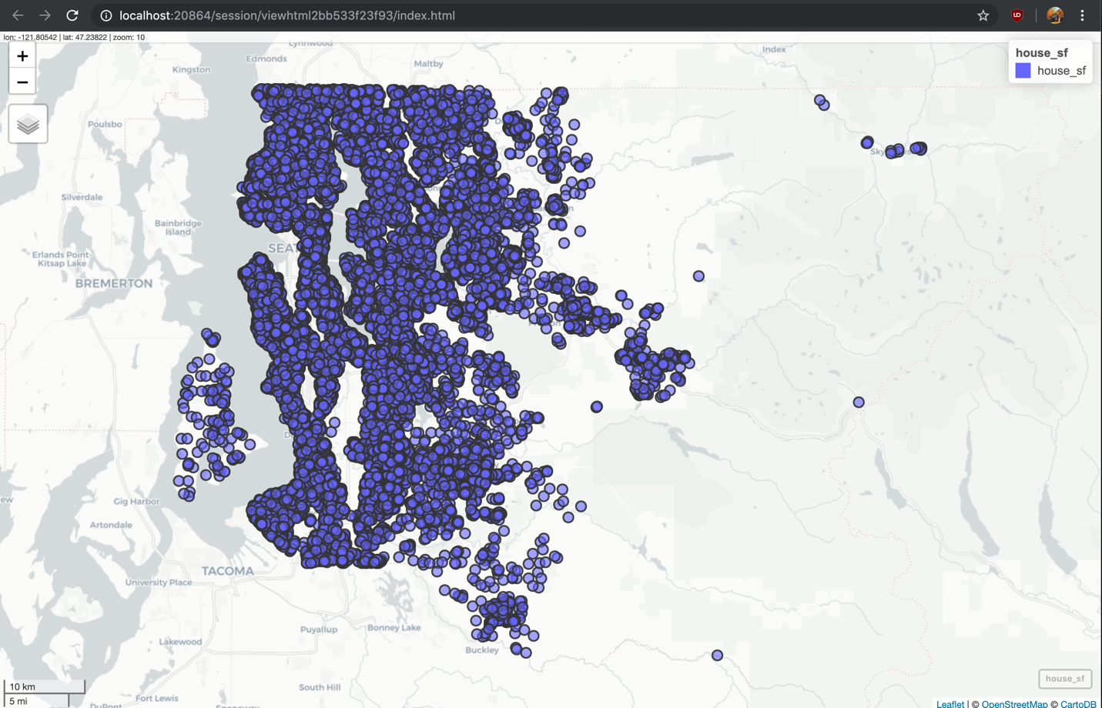

As mentioned previously, due to most houses not having views, it made more sense to binarize this variable into no view (0) or view (1).

#house_mod is now dataset with the transformed variables and new features added  
house_mod <- house_log  
  
house_mod$view= ifelse(house_mod$view != '0', '1', '0')  
house_mod <- house_mod %>% mutate(view = as.factor(view))  
  
summary(house_mod)

## date price bedrooms   
## Min. :2014-05-02 00:00:00 Min. : 75000 Min. : 0.000   
## 1st Qu.:2014-07-22 00:00:00 1st Qu.: 321950 1st Qu.: 3.000   
## Median :2014-10-16 00:00:00 Median : 450000 Median : 3.000   
## Mean :2014-10-29 04:38:01 Mean : 540088 Mean : 3.371   
## 3rd Qu.:2015-02-17 00:00:00 3rd Qu.: 645000 3rd Qu.: 4.000   
## Max. :2015-05-27 00:00:00 Max. :7700000 Max. :33.000   
## bathrooms sqft_living sqft_lot floors   
## Min. :0.000 Min. : 290 Min. : 520 Min. :1.000   
## 1st Qu.:1.750 1st Qu.: 1427 1st Qu.: 5040 1st Qu.:1.000   
## Median :2.250 Median : 1910 Median : 7618 Median :1.500   
## Mean :2.115 Mean : 2080 Mean : 15107 Mean :1.494   
## 3rd Qu.:2.500 3rd Qu.: 2550 3rd Qu.: 10688 3rd Qu.:2.000   
## Max. :8.000 Max. :13540 Max. :1651359 Max. :3.500   
## view condition grade yr_built   
## 0:19489 Min. :1.000 Min. : 1.000 Min. :1900   
## 1: 2124 1st Qu.:3.000 1st Qu.: 7.000 1st Qu.:1951   
## Median :3.000 Median : 7.000 Median :1975   
## Mean :3.409 Mean : 7.657 Mean :1971   
## 3rd Qu.:4.000 3rd Qu.: 8.000 3rd Qu.:1997   
## Max. :5.000 Max. :13.000 Max. :2015   
## yr_renovated lat long log_price   
## Min. : 0.0 Min. :47.16 Min. :-122.5 Min. :4.875   
## 1st Qu.: 0.0 1st Qu.:47.47 1st Qu.:-122.3 1st Qu.:5.508   
## Median : 0.0 Median :47.57 Median :-122.2 Median :5.653   
## Mean : 84.4 Mean :47.56 Mean :-122.2 Mean :5.667   
## 3rd Qu.: 0.0 3rd Qu.:47.68 3rd Qu.:-122.1 3rd Qu.:5.810   
## Max. :2015.0 Max. :47.78 Max. :-121.3 Max. :6.886   
## log_sqft_living log_sqft_lot   
## Min. :2.464 Min. :2.717   
## 1st Qu.:3.155 1st Qu.:3.703   
## Median :3.281 Median :3.882   
## Mean :3.279 Mean :3.904   
## 3rd Qu.:3.407 3rd Qu.:4.029   
## Max. :4.132 Max. :6.218

I also removed observations where ‘bathroom’ was ‘0’- I was skeptical these houses did not in reality have bathrooms so I assumed these were missing data. This only amounted in 10 observations removed.

house_bthrm <- house_mod %>%   
 group_by(bathrooms) %>%  
 summarize(n = n())  
house_bthrm

## # A tibble: 30 x 2  
## bathrooms n  
## <dbl> <int>  
## 1 0 10  
## 2 0.5 4  
## 3 0.75 72  
## 4 1 3852  
## 5 1.25 9  
## 6 1.5 1446  
## 7 1.75 3048  
## 8 2 1930  
## 9 2.25 2047  
## 10 2.5 5380  
## # … with 20 more rows

house_mod <- filter(house_mod, bathrooms != 0)  
summary(house_mod)

## date price bedrooms   
## Min. :2014-05-02 00:00:00 Min. : 78000 Min. : 0.000   
## 1st Qu.:2014-07-22 00:00:00 1st Qu.: 322000 1st Qu.: 3.000   
## Median :2014-10-16 00:00:00 Median : 450000 Median : 3.000   
## Mean :2014-10-29 04:19:33 Mean : 540131 Mean : 3.372   
## 3rd Qu.:2015-02-17 00:00:00 3rd Qu.: 645000 3rd Qu.: 4.000   
## Max. :2015-05-27 00:00:00 Max. :7700000 Max. :33.000   
## bathrooms sqft_living sqft_lot floors   
## Min. :0.500 Min. : 370 Min. : 520 Min. :1.000   
## 1st Qu.:1.750 1st Qu.: 1430 1st Qu.: 5040 1st Qu.:1.000   
## Median :2.250 Median : 1910 Median : 7617 Median :1.500   
## Mean :2.116 Mean : 2080 Mean : 15106 Mean :1.494   
## 3rd Qu.:2.500 3rd Qu.: 2550 3rd Qu.: 10684 3rd Qu.:2.000   
## Max. :8.000 Max. :13540 Max. :1651359 Max. :3.500   
## view condition grade yr_built   
## 0:19481 Min. :1.00 Min. : 3.000 Min. :1900   
## 1: 2122 1st Qu.:3.00 1st Qu.: 7.000 1st Qu.:1951   
## Median :3.00 Median : 7.000 Median :1975   
## Mean :3.41 Mean : 7.658 Mean :1971   
## 3rd Qu.:4.00 3rd Qu.: 8.000 3rd Qu.:1997   
## Max. :5.00 Max. :13.000 Max. :2015   
## yr_renovated lat long log_price   
## Min. : 0.00 Min. :47.16 Min. :-122.5 Min. :4.892   
## 1st Qu.: 0.00 1st Qu.:47.47 1st Qu.:-122.3 1st Qu.:5.508   
## Median : 0.00 Median :47.57 Median :-122.2 Median :5.653   
## Mean : 84.44 Mean :47.56 Mean :-122.2 Mean :5.667   
## 3rd Qu.: 0.00 3rd Qu.:47.68 3rd Qu.:-122.1 3rd Qu.:5.810   
## Max. :2015.00 Max. :47.78 Max. :-121.3 Max. :6.886   
## log_sqft_living log_sqft_lot   
## Min. :2.569 Min. :2.717   
## 1st Qu.:3.156 1st Qu.:3.703   
## Median :3.281 Median :3.882   
## Mean :3.279 Mean :3.904   
## 3rd Qu.:3.407 3rd Qu.:4.029   
## Max. :4.132 Max. :6.218

Here the date variable, ‘dttm’ was changed to a date data type and a new date variable, ‘month,’ was created that grouped the sales into each of the 13 months represented in the data set.

library(lubridate)

##   
## Attaching package: 'lubridate'

## The following object is masked from 'package:reshape':  
##   
## stamp

## The following object is masked from 'package:base':  
##   
## date

house_mod$dttm = house_mod$date  
house_mod <- house_mod %>% mutate(date = as_date(date))  
  
glimpse(house_mod)

## Observations: 21,603  
## Variables: 18  
## $ date <date> 2014-10-13, 2014-12-09, 2015-02-25, 2014-12-09,…  
## $ price <dbl> 221900, 538000, 180000, 604000, 510000, 1225000,…  
## $ bedrooms <dbl> 3, 3, 2, 4, 3, 4, 3, 3, 3, 3, 3, 2, 3, 3, 5, 4, …  
## $ bathrooms <dbl> 1.00, 2.25, 1.00, 3.00, 2.00, 4.50, 2.25, 1.50, …  
## $ sqft_living <dbl> 1180, 2570, 770, 1960, 1680, 5420, 1715, 1060, 1…  
## $ sqft_lot <dbl> 5650, 7242, 10000, 5000, 8080, 101930, 6819, 971…  
## $ floors <dbl> 1.0, 2.0, 1.0, 1.0, 1.0, 1.0, 2.0, 1.0, 1.0, 2.0…  
## $ view <fct> 0, 0, 0, 0, 0, 0, 0, 0, 0, 0, 0, 0, 0, 0, 0, 1, …  
## $ condition <dbl> 3, 3, 3, 5, 3, 3, 3, 3, 3, 3, 3, 4, 4, 4, 3, 3, …  
## $ grade <dbl> 7, 7, 6, 7, 8, 11, 7, 7, 7, 7, 8, 7, 7, 7, 7, 9,…  
## $ yr_built <dbl> 1955, 1951, 1933, 1965, 1987, 2001, 1995, 1963, …  
## $ yr_renovated <dbl> 0, 1991, 0, 0, 0, 0, 0, 0, 0, 0, 0, 0, 0, 0, 0, …  
## $ lat <dbl> 47.5112, 47.7210, 47.7379, 47.5208, 47.6168, 47.…  
## $ long <dbl> -122.257, -122.319, -122.233, -122.393, -122.045…  
## $ log_price <dbl> 5.346159, 5.730783, 5.255275, 5.781038, 5.707571…  
## $ log_sqft_living <dbl> 3.072250, 3.410102, 2.887054, 3.292478, 3.225568…  
## $ log_sqft_lot <dbl> 3.752125, 3.859918, 4.000043, 3.699057, 3.907465…  
## $ dttm <dttm> 2014-10-13, 2014-12-09, 2015-02-25, 2014-12-09,…

#house_month new dataset with month variable added  
  
house_month <- house_mod  
  
house_month$month = ifelse(str_detect(house_month$date, "^2014-05"), 'May14',   
 ifelse(str_detect(house_month$date, "^2014-06"), 'Jun14',   
 ifelse(str_detect(house_month$date, "^2014-07"), 'Jul14',  
 ifelse(str_detect(house_month$date, "^2014-08"), 'Aug14',  
 ifelse(str_detect(house_month$date, "^2014-09"), 'Sep14',  
 ifelse(str_detect(house_month$date, "^2014-10"), 'Oct14',  
 ifelse(str_detect(house_month$date, "^2014-11"), 'Nov14',  
 ifelse(str_detect(house_month$date, "^2014-12"), 'Dec14',  
 ifelse(str_detect(house_month$date, "^2015-01"), 'Jan15',  
 ifelse(str_detect(house_month$date, "^2015-02"), 'Feb15',  
 ifelse(str_detect(house_month$date, "^2015-03"), 'Mar15',  
 ifelse(str_detect(house_month$date, "^2015-04"), 'Apr15',  
 'May15'))))))))))))  
  
house_month$month = factor(house_month$month,  
 levels = c('May14', 'Jun14', 'Jul14', 'Aug14', 'Sep14', 'Oct14',  
 'Nov14', 'Dec14', 'Jan15', 'Feb15', 'Mar15', 'Apr15', 'May15'  
 ))  
glimpse(house_month)

## Observations: 21,603  
## Variables: 19  
## $ date <date> 2014-10-13, 2014-12-09, 2015-02-25, 2014-12-09,…  
## $ price <dbl> 221900, 538000, 180000, 604000, 510000, 1225000,…  
## $ bedrooms <dbl> 3, 3, 2, 4, 3, 4, 3, 3, 3, 3, 3, 2, 3, 3, 5, 4, …  
## $ bathrooms <dbl> 1.00, 2.25, 1.00, 3.00, 2.00, 4.50, 2.25, 1.50, …  
## $ sqft_living <dbl> 1180, 2570, 770, 1960, 1680, 5420, 1715, 1060, 1…  
## $ sqft_lot <dbl> 5650, 7242, 10000, 5000, 8080, 101930, 6819, 971…  
## $ floors <dbl> 1.0, 2.0, 1.0, 1.0, 1.0, 1.0, 2.0, 1.0, 1.0, 2.0…  
## $ view <fct> 0, 0, 0, 0, 0, 0, 0, 0, 0, 0, 0, 0, 0, 0, 0, 1, …  
## $ condition <dbl> 3, 3, 3, 5, 3, 3, 3, 3, 3, 3, 3, 4, 4, 4, 3, 3, …  
## $ grade <dbl> 7, 7, 6, 7, 8, 11, 7, 7, 7, 7, 8, 7, 7, 7, 7, 9,…  
## $ yr_built <dbl> 1955, 1951, 1933, 1965, 1987, 2001, 1995, 1963, …  
## $ yr_renovated <dbl> 0, 1991, 0, 0, 0, 0, 0, 0, 0, 0, 0, 0, 0, 0, 0, …  
## $ lat <dbl> 47.5112, 47.7210, 47.7379, 47.5208, 47.6168, 47.…  
## $ long <dbl> -122.257, -122.319, -122.233, -122.393, -122.045…  
## $ log_price <dbl> 5.346159, 5.730783, 5.255275, 5.781038, 5.707571…  
## $ log_sqft_living <dbl> 3.072250, 3.410102, 2.887054, 3.292478, 3.225568…  
## $ log_sqft_lot <dbl> 3.752125, 3.859918, 4.000043, 3.699057, 3.907465…  
## $ dttm <dttm> 2014-10-13, 2014-12-09, 2015-02-25, 2014-12-09,…  
## $ month <fct> Oct14, Dec14, Feb15, Dec14, Feb15, May14, Jun14,…

I wanted to better explore any time trends by comparing sales number to the median sales price, so I created a stacked dot/line and bar plot. In the plot, the median price and count of sales followed a similar trend, and even here we can see some seasonality effect, where sales and price were down in the colder months and picked back up in the Spring. We would need to pull in other data to determine what else might be affecting trends in price and sales volume.

house_date <- house_month %>%   
 group_by(month) %>%  
 summarize(n = n(),  
 price_median = median(price))  
house_date

## # A tibble: 13 x 3  
## month n price_median  
## <fct> <int> <dbl>  
## 1 May14 1768 465000  
## 2 Jun14 2178 465000  
## 3 Jul14 2211 465000  
## 4 Aug14 1940 442100  
## 5 Sep14 1772 450000  
## 6 Oct14 1878 446900  
## 7 Nov14 1410 435000  
## 8 Dec14 1470 432500  
## 9 Jan15 978 438500  
## 10 Feb15 1248 426045  
## 11 Mar15 1875 450000  
## 12 Apr15 2229 477000  
## 13 May15 646 455000

d <- ggplot(house_month, aes(month))  
p1 <- d + stat_summary_bin(aes(y = price), fun.y = "median", geom = "point", color="steelblue4", size=2.5) +   
 stat_summary_bin(aes(y = price, group=1), fun.y = "median", geom = "line", color="cornflowerblue", size=1) +   
 theme_minimal() +   
 theme(plot.title = element_text(size=25, face="bold", hjust = .5),  
 axis.title.y = element_text(size=14, face="bold")) +  
 theme(axis.title.x = element_blank(), axis.text.x = element_blank()) +   
 ggtitle("House Sales: Median Price and Count by Month") +  
 ylab("Price")  
  
p2 <- ggplot(house_month, aes(x = month)) +  
 geom_bar(fill="steelblue4", color="cornflowerblue", size=.8) +  
 theme_minimal() +  
 xlab("Month") +  
 ylab("Count") +  
 theme(axis.title.x = element_text(size=14, face="bold"),  
 axis.title.y = element_text(size=14, face="bold"))  
  
library(grid)  
grid.newpage()  
grid.draw(rbind(ggplotGrob(p1), ggplotGrob(p2), size = "last"))

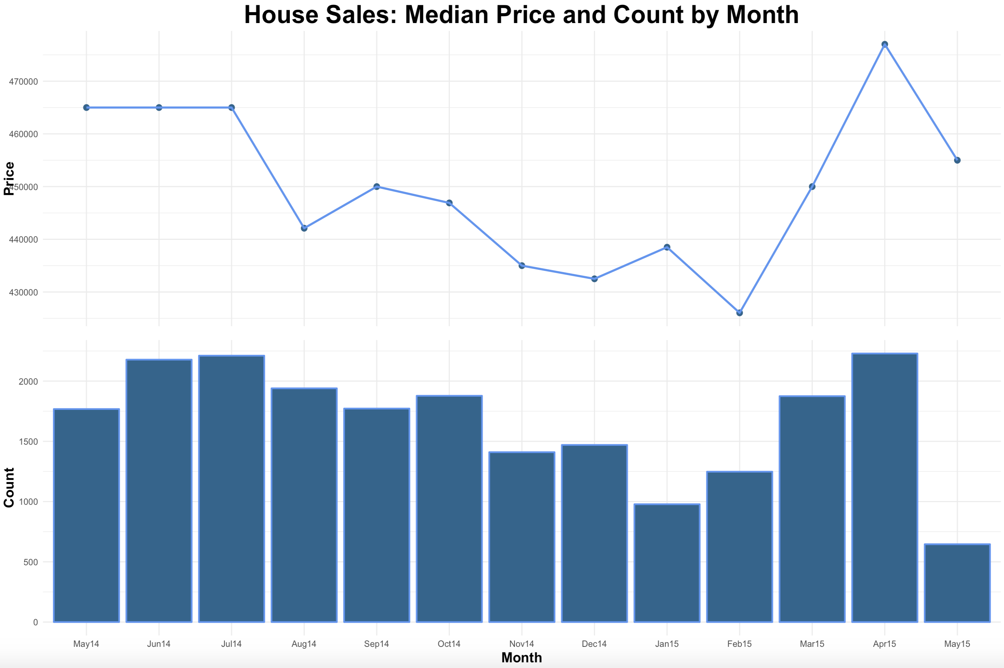

As the new month variable was a multi-level factor type, model.matrix and cbind had to be applied to binarize ‘month’ for use in the train and test sets for modeling.

month = model.matrix(~ month - 1, data = house_month)  
  
house_bind = cbind(house_month, month)  
  
glimpse(house_bind)

## Observations: 21,603  
## Variables: 32  
## $ date <date> 2014-10-13, 2014-12-09, 2015-02-25, 2014-12-09,…  
## $ price <dbl> 221900, 538000, 180000, 604000, 510000, 1225000,…  
## $ bedrooms <dbl> 3, 3, 2, 4, 3, 4, 3, 3, 3, 3, 3, 2, 3, 3, 5, 4, …  
## $ bathrooms <dbl> 1.00, 2.25, 1.00, 3.00, 2.00, 4.50, 2.25, 1.50, …  
## $ sqft_living <dbl> 1180, 2570, 770, 1960, 1680, 5420, 1715, 1060, 1…  
## $ sqft_lot <dbl> 5650, 7242, 10000, 5000, 8080, 101930, 6819, 971…  
## $ floors <dbl> 1.0, 2.0, 1.0, 1.0, 1.0, 1.0, 2.0, 1.0, 1.0, 2.0…  
## $ view <fct> 0, 0, 0, 0, 0, 0, 0, 0, 0, 0, 0, 0, 0, 0, 0, 1, …  
## $ condition <dbl> 3, 3, 3, 5, 3, 3, 3, 3, 3, 3, 3, 4, 4, 4, 3, 3, …  
## $ grade <dbl> 7, 7, 6, 7, 8, 11, 7, 7, 7, 7, 8, 7, 7, 7, 7, 9,…  
## $ yr_built <dbl> 1955, 1951, 1933, 1965, 1987, 2001, 1995, 1963, …  
## $ yr_renovated <dbl> 0, 1991, 0, 0, 0, 0, 0, 0, 0, 0, 0, 0, 0, 0, 0, …  
## $ lat <dbl> 47.5112, 47.7210, 47.7379, 47.5208, 47.6168, 47.…  
## $ long <dbl> -122.257, -122.319, -122.233, -122.393, -122.045…  
## $ log_price <dbl> 5.346159, 5.730783, 5.255275, 5.781038, 5.707571…  
## $ log_sqft_living <dbl> 3.072250, 3.410102, 2.887054, 3.292478, 3.225568…  
## $ log_sqft_lot <dbl> 3.752125, 3.859918, 4.000043, 3.699057, 3.907465…  
## $ dttm <dttm> 2014-10-13, 2014-12-09, 2015-02-25, 2014-12-09,…  
## $ month <fct> Oct14, Dec14, Feb15, Dec14, Feb15, May14, Jun14,…  
## $ monthMay14 <dbl> 0, 0, 0, 0, 0, 1, 0, 0, 0, 0, 0, 1, 1, 0, 0, 0, …  
## $ monthJun14 <dbl> 0, 0, 0, 0, 0, 0, 1, 0, 0, 0, 0, 0, 0, 0, 0, 0, …  
## $ monthJul14 <dbl> 0, 0, 0, 0, 0, 0, 0, 0, 0, 0, 0, 0, 0, 0, 0, 0, …  
## $ monthAug14 <dbl> 0, 0, 0, 0, 0, 0, 0, 0, 0, 0, 0, 0, 0, 0, 0, 0, …  
## $ monthSep14 <dbl> 0, 0, 0, 0, 0, 0, 0, 0, 0, 0, 0, 0, 0, 0, 0, 0, …  
## $ monthOct14 <dbl> 1, 0, 0, 0, 0, 0, 0, 0, 0, 0, 0, 0, 0, 1, 0, 0, …  
## $ monthNov14 <dbl> 0, 0, 0, 0, 0, 0, 0, 0, 0, 0, 0, 0, 0, 0, 0, 0, …  
## $ monthDec14 <dbl> 0, 1, 0, 1, 0, 0, 0, 0, 0, 0, 0, 0, 0, 0, 0, 0, …  
## $ monthJan15 <dbl> 0, 0, 0, 0, 0, 0, 0, 1, 0, 0, 0, 0, 0, 0, 0, 1, …  
## $ monthFeb15 <dbl> 0, 0, 1, 0, 1, 0, 0, 0, 0, 0, 0, 0, 0, 0, 0, 0, …  
## $ monthMar15 <dbl> 0, 0, 0, 0, 0, 0, 0, 0, 0, 1, 0, 0, 0, 0, 1, 0, …  
## $ monthApr15 <dbl> 0, 0, 0, 0, 0, 0, 0, 0, 1, 0, 1, 0, 0, 0, 0, 0, …  
## $ monthMay15 <dbl> 0, 0, 0, 0, 0, 0, 0, 0, 0, 0, 0, 0, 0, 0, 0, 0, …

The original date variables as well as the original variables I performed logged transformations on were removed in the train and test sets for modeling.

#new dataset for modeling, house_model, deselecting original unmodified variables  
house_model <- house_bind %>% select(-date, -dttm, -month, -price, -sqft_living, -sqft_lot)  
  
glimpse(house_model)

## Observations: 21,603  
## Variables: 26  
## $ bedrooms <dbl> 3, 3, 2, 4, 3, 4, 3, 3, 3, 3, 3, 2, 3, 3, 5, 4, …  
## $ bathrooms <dbl> 1.00, 2.25, 1.00, 3.00, 2.00, 4.50, 2.25, 1.50, …  
## $ floors <dbl> 1.0, 2.0, 1.0, 1.0, 1.0, 1.0, 2.0, 1.0, 1.0, 2.0…  
## $ view <fct> 0, 0, 0, 0, 0, 0, 0, 0, 0, 0, 0, 0, 0, 0, 0, 1, …  
## $ condition <dbl> 3, 3, 3, 5, 3, 3, 3, 3, 3, 3, 3, 4, 4, 4, 3, 3, …  
## $ grade <dbl> 7, 7, 6, 7, 8, 11, 7, 7, 7, 7, 8, 7, 7, 7, 7, 9,…  
## $ yr_built <dbl> 1955, 1951, 1933, 1965, 1987, 2001, 1995, 1963, …  
## $ yr_renovated <dbl> 0, 1991, 0, 0, 0, 0, 0, 0, 0, 0, 0, 0, 0, 0, 0, …  
## $ lat <dbl> 47.5112, 47.7210, 47.7379, 47.5208, 47.6168, 47.…  
## $ long <dbl> -122.257, -122.319, -122.233, -122.393, -122.045…  
## $ log_price <dbl> 5.346159, 5.730783, 5.255275, 5.781038, 5.707571…  
## $ log_sqft_living <dbl> 3.072250, 3.410102, 2.887054, 3.292478, 3.225568…  
## $ log_sqft_lot <dbl> 3.752125, 3.859918, 4.000043, 3.699057, 3.907465…  
## $ monthMay14 <dbl> 0, 0, 0, 0, 0, 1, 0, 0, 0, 0, 0, 1, 1, 0, 0, 0, …  
## $ monthJun14 <dbl> 0, 0, 0, 0, 0, 0, 1, 0, 0, 0, 0, 0, 0, 0, 0, 0, …  
## $ monthJul14 <dbl> 0, 0, 0, 0, 0, 0, 0, 0, 0, 0, 0, 0, 0, 0, 0, 0, …  
## $ monthAug14 <dbl> 0, 0, 0, 0, 0, 0, 0, 0, 0, 0, 0, 0, 0, 0, 0, 0, …  
## $ monthSep14 <dbl> 0, 0, 0, 0, 0, 0, 0, 0, 0, 0, 0, 0, 0, 0, 0, 0, …  
## $ monthOct14 <dbl> 1, 0, 0, 0, 0, 0, 0, 0, 0, 0, 0, 0, 0, 1, 0, 0, …  
## $ monthNov14 <dbl> 0, 0, 0, 0, 0, 0, 0, 0, 0, 0, 0, 0, 0, 0, 0, 0, …  
## $ monthDec14 <dbl> 0, 1, 0, 1, 0, 0, 0, 0, 0, 0, 0, 0, 0, 0, 0, 0, …  
## $ monthJan15 <dbl> 0, 0, 0, 0, 0, 0, 0, 1, 0, 0, 0, 0, 0, 0, 0, 1, …  
## $ monthFeb15 <dbl> 0, 0, 1, 0, 1, 0, 0, 0, 0, 0, 0, 0, 0, 0, 0, 0, …  
## $ monthMar15 <dbl> 0, 0, 0, 0, 0, 0, 0, 0, 0, 1, 0, 0, 0, 0, 1, 0, …  
## $ monthApr15 <dbl> 0, 0, 0, 0, 0, 0, 0, 0, 1, 0, 1, 0, 0, 0, 0, 0, …  
## $ monthMay15 <dbl> 0, 0, 0, 0, 0, 0, 0, 0, 0, 0, 0, 0, 0, 0, 0, 0, …

summary(house_model)

## bedrooms bathrooms floors view condition   
## Min. : 0.000 Min. :0.500 Min. :1.000 0:19481 Min. :1.00   
## 1st Qu.: 3.000 1st Qu.:1.750 1st Qu.:1.000 1: 2122 1st Qu.:3.00   
## Median : 3.000 Median :2.250 Median :1.500 Median :3.00   
## Mean : 3.372 Mean :2.116 Mean :1.494 Mean :3.41   
## 3rd Qu.: 4.000 3rd Qu.:2.500 3rd Qu.:2.000 3rd Qu.:4.00   
## Max. :33.000 Max. :8.000 Max. :3.500 Max. :5.00   
## grade yr_built yr_renovated lat   
## Min. : 3.000 Min. :1900 Min. : 0.00 Min. :47.16   
## 1st Qu.: 7.000 1st Qu.:1951 1st Qu.: 0.00 1st Qu.:47.47   
## Median : 7.000 Median :1975 Median : 0.00 Median :47.57   
## Mean : 7.658 Mean :1971 Mean : 84.44 Mean :47.56   
## 3rd Qu.: 8.000 3rd Qu.:1997 3rd Qu.: 0.00 3rd Qu.:47.68   
## Max. :13.000 Max. :2015 Max. :2015.00 Max. :47.78   
## long log_price log_sqft_living log_sqft_lot   
## Min. :-122.5 Min. :4.892 Min. :2.569 Min. :2.717   
## 1st Qu.:-122.3 1st Qu.:5.508 1st Qu.:3.156 1st Qu.:3.703   
## Median :-122.2 Median :5.653 Median :3.281 Median :3.882   
## Mean :-122.2 Mean :5.667 Mean :3.279 Mean :3.904   
## 3rd Qu.:-122.1 3rd Qu.:5.810 3rd Qu.:3.407 3rd Qu.:4.029   
## Max. :-121.3 Max. :6.886 Max. :4.132 Max. :6.218   
## monthMay14 monthJun14 monthJul14 monthAug14   
## Min. :0.00000 Min. :0.0000 Min. :0.0000 Min. :0.0000   
## 1st Qu.:0.00000 1st Qu.:0.0000 1st Qu.:0.0000 1st Qu.:0.0000   
## Median :0.00000 Median :0.0000 Median :0.0000 Median :0.0000   
## Mean :0.08184 Mean :0.1008 Mean :0.1023 Mean :0.0898   
## 3rd Qu.:0.00000 3rd Qu.:0.0000 3rd Qu.:0.0000 3rd Qu.:0.0000   
## Max. :1.00000 Max. :1.0000 Max. :1.0000 Max. :1.0000   
## monthSep14 monthOct14 monthNov14 monthDec14   
## Min. :0.00000 Min. :0.00000 Min. :0.00000 Min. :0.00000   
## 1st Qu.:0.00000 1st Qu.:0.00000 1st Qu.:0.00000 1st Qu.:0.00000   
## Median :0.00000 Median :0.00000 Median :0.00000 Median :0.00000   
## Mean :0.08203 Mean :0.08693 Mean :0.06527 Mean :0.06805   
## 3rd Qu.:0.00000 3rd Qu.:0.00000 3rd Qu.:0.00000 3rd Qu.:0.00000   
## Max. :1.00000 Max. :1.00000 Max. :1.00000 Max. :1.00000   
## monthJan15 monthFeb15 monthMar15 monthApr15   
## Min. :0.00000 Min. :0.00000 Min. :0.00000 Min. :0.0000   
## 1st Qu.:0.00000 1st Qu.:0.00000 1st Qu.:0.00000 1st Qu.:0.0000   
## Median :0.00000 Median :0.00000 Median :0.00000 Median :0.0000   
## Mean :0.04527 Mean :0.05777 Mean :0.08679 Mean :0.1032   
## 3rd Qu.:0.00000 3rd Qu.:0.00000 3rd Qu.:0.00000 3rd Qu.:0.0000   
## Max. :1.00000 Max. :1.00000 Max. :1.00000 Max. :1.0000   
## monthMay15   
## Min. :0.0000   
## 1st Qu.:0.0000   
## Median :0.0000   
## Mean :0.0299   
## 3rd Qu.:0.0000   
## Max. :1.0000

## Splitting dataset into train and test sets.

in_train = createDataPartition(y = house_model$log_price,  
 p = 0.80,  
 list = FALSE)  
  
house_train = house_model[in_train, ]  
house_test = house_model[-in_train, ]

#identify any vars w/near zero variance with nearZeroVar  
nearZeroVar(house_model, saveMetrics = TRUE)

## freqRatio percentUnique zeroVar nzv  
## bedrooms 1.427492 0.060176827 FALSE FALSE  
## bathrooms 1.396677 0.134240615 FALSE FALSE  
## floors 1.295824 0.027773920 FALSE FALSE  
## view 9.180490 0.009257973 FALSE FALSE  
## condition 2.470495 0.023144934 FALSE FALSE  
## grade 1.479888 0.050918854 FALSE FALSE  
## yr_built 1.233996 0.536962459 FALSE FALSE  
## yr_renovated 227.351648 0.324029070 FALSE TRUE  
## lat 1.000000 23.297690136 FALSE FALSE  
## long 1.045045 3.480998010 FALSE FALSE  
## log_price 1.011628 18.603897607 FALSE FALSE  
## log_sqft_living 1.022222 4.791001250 FALSE FALSE  
## log_sqft_lot 1.234483 45.257603111 FALSE FALSE  
## monthMay14 11.218891 0.009257973 FALSE FALSE  
## monthJun14 8.918733 0.009257973 FALSE FALSE  
## monthJul14 8.770692 0.009257973 FALSE FALSE  
## monthAug14 10.135567 0.009257973 FALSE FALSE  
## monthSep14 11.191309 0.009257973 FALSE FALSE  
## monthOct14 10.503195 0.009257973 FALSE FALSE  
## monthNov14 14.321277 0.009257973 FALSE FALSE  
## monthDec14 13.695918 0.009257973 FALSE FALSE  
## monthJan15 21.088957 0.009257973 FALSE TRUE  
## monthFeb15 16.310096 0.009257973 FALSE FALSE  
## monthMar15 10.521600 0.009257973 FALSE FALSE  
## monthApr15 8.691790 0.009257973 FALSE FALSE  
## monthMay15 32.441176 0.009257973 FALSE TRUE

## Incorporating preprocessing into our train and test sets.

Here preprocessing (centering, scaling, and removal of variables with no/close to zero variance) was applied to the numeric and non-binary variables in the dataset.

preprocess_steps = preProcess(select(house_train, bedrooms, bathrooms, floors, condition, grade, yr_built, log_sqft_living, log_sqft_lot, condition, grade, yr_built, yr_renovated, lat, long), method=c("center", "scale", "nzv"))  
  
house_train_proc = predict(preprocess_steps, newdata = house_train)  
house_test_proc = predict(preprocess_steps, newdata = house_test)  
  
glimpse(house_train_proc)

## Observations: 17,283  
## Variables: 25  
## $ bedrooms <dbl> -0.3981857, -1.4659658, 0.6695945, 0.6695945, -0…  
## $ bathrooms <dbl> 0.1742275, -1.4590844, 1.1542146, 3.1141889, 0.1…  
## $ floors <dbl> 0.9394718, -0.9175524, -0.9175524, -0.9175524, 0…  
## $ view <fct> 0, 0, 0, 0, 0, 0, 0, 0, 0, 0, 1, 0, 0, 0, 0, 0, …  
## $ condition <dbl> -0.6320668, -0.6320668, 2.4481560, -0.6320668, -…  
## $ grade <dbl> -0.5639661, -1.4170974, -0.5639661, 2.8485593, -…  
## $ yr_built <dbl> -0.68693067, -1.30074483, -0.20951967, 1.0181086…  
## $ lat <dbl> 1.16259571, 1.28405871, -0.27627361, 0.69614906,…  
## $ long <dbl> -0.74837619, -0.14047537, -1.27145365, 1.4711686…  
## $ log_price <dbl> 5.730783, 5.255275, 5.781038, 6.088136, 5.410779…  
## $ log_sqft_living <dbl> 0.71020643, -2.13670101, 0.06998563, 2.47358953,…  
## $ log_sqft_lot <dbl> -0.11654044, 0.23964518, -0.52543696, 2.80256316…  
## $ monthMay14 <dbl> 0, 0, 0, 1, 0, 0, 0, 0, 1, 0, 0, 1, 0, 0, 1, 0, …  
## $ monthJun14 <dbl> 0, 0, 0, 0, 1, 0, 0, 0, 0, 0, 0, 0, 0, 0, 0, 0, …  
## $ monthJul14 <dbl> 0, 0, 0, 0, 0, 0, 0, 0, 0, 0, 0, 0, 0, 0, 0, 1, …  
## $ monthAug14 <dbl> 0, 0, 0, 0, 0, 0, 0, 0, 0, 0, 0, 0, 0, 0, 0, 0, …  
## $ monthSep14 <dbl> 0, 0, 0, 0, 0, 0, 0, 0, 0, 0, 0, 0, 0, 0, 0, 0, …  
## $ monthOct14 <dbl> 0, 0, 0, 0, 0, 0, 0, 0, 0, 0, 0, 0, 0, 0, 0, 0, …  
## $ monthNov14 <dbl> 0, 0, 0, 0, 0, 0, 0, 0, 0, 0, 0, 0, 0, 0, 0, 0, …  
## $ monthDec14 <dbl> 1, 0, 1, 0, 0, 0, 0, 0, 0, 0, 0, 0, 1, 0, 0, 0, …  
## $ monthJan15 <dbl> 0, 0, 0, 0, 0, 1, 0, 0, 0, 0, 1, 0, 0, 0, 0, 0, …  
## $ monthFeb15 <dbl> 0, 1, 0, 0, 0, 0, 0, 0, 0, 0, 0, 0, 0, 0, 0, 0, …  
## $ monthMar15 <dbl> 0, 0, 0, 0, 0, 0, 0, 1, 0, 1, 0, 0, 0, 0, 0, 0, …  
## $ monthApr15 <dbl> 0, 0, 0, 0, 0, 0, 1, 0, 0, 0, 0, 0, 0, 1, 0, 0, …  
## $ monthMay15 <dbl> 0, 0, 0, 0, 0, 0, 0, 0, 0, 0, 0, 0, 0, 0, 0, 0, …

glimpse(house_test_proc)

## Observations: 4,320  
## Variables: 25  
## $ bedrooms <dbl> -0.3981857, -0.3981857, -0.3981857, -0.3981857, …  
## $ bathrooms <dbl> -1.4590844, -0.1524349, 0.5008899, -1.4590844, -…  
## $ floors <dbl> -0.9175524, -0.9175524, -0.9175524, 0.0109597, -…  
## $ view <fct> 0, 0, 0, 0, 0, 0, 1, 0, 0, 0, 0, 0, 0, 0, 0, 1, …  
## $ condition <dbl> -0.6320668, -0.6320668, -0.6320668, 0.9080446, 0…  
## $ grade <dbl> -0.5639661, 0.2891653, 0.2891653, -0.5639661, -0…  
## $ yr_built <dbl> -0.55052753, 0.54069763, -0.20951967, -1.5053495…  
## $ lat <dbl> -0.34527034, 0.41369370, 0.29798043, 1.41270886,…  
## $ long <dbl> -0.3101221, 1.1884241, 0.4815627, -0.1122009, 1.…  
## $ log_price <dbl> 5.346159, 5.707571, 5.821187, 5.491363, 5.602061…  
## $ log_sqft_living <dbl> -1.12869638, -0.29419958, 1.48021594, -0.6748126…  
## $ log_sqft_lot <dbl> -0.390541486, 0.004319004, 0.216894234, 0.999304…  
## $ monthMay14 <dbl> 0, 0, 0, 1, 0, 0, 0, 0, 0, 0, 0, 1, 0, 0, 1, 0, …  
## $ monthJun14 <dbl> 0, 0, 0, 0, 0, 0, 0, 0, 0, 0, 0, 0, 0, 0, 0, 0, …  
## $ monthJul14 <dbl> 0, 0, 0, 0, 0, 1, 0, 0, 0, 0, 0, 0, 0, 0, 0, 0, …  
## $ monthAug14 <dbl> 0, 0, 0, 0, 0, 0, 1, 0, 0, 0, 0, 0, 0, 0, 0, 1, …  
## $ monthSep14 <dbl> 0, 0, 0, 0, 0, 0, 0, 0, 0, 0, 0, 0, 0, 0, 0, 0, …  
## $ monthOct14 <dbl> 1, 0, 0, 0, 1, 0, 0, 0, 0, 0, 0, 0, 0, 0, 0, 0, …  
## $ monthNov14 <dbl> 0, 0, 0, 0, 0, 0, 0, 0, 0, 1, 0, 0, 0, 0, 0, 0, …  
## $ monthDec14 <dbl> 0, 0, 0, 0, 0, 0, 0, 1, 1, 0, 1, 0, 1, 0, 0, 0, …  
## $ monthJan15 <dbl> 0, 0, 0, 0, 0, 0, 0, 0, 0, 0, 0, 0, 0, 0, 0, 0, …  
## $ monthFeb15 <dbl> 0, 1, 0, 0, 0, 0, 0, 0, 0, 0, 0, 0, 0, 0, 0, 0, …  
## $ monthMar15 <dbl> 0, 0, 0, 0, 0, 0, 0, 0, 0, 0, 0, 0, 0, 0, 0, 0, …  
## $ monthApr15 <dbl> 0, 0, 1, 0, 0, 0, 0, 0, 0, 0, 0, 0, 0, 1, 0, 0, …  
## $ monthMay15 <dbl> 0, 0, 0, 0, 0, 0, 0, 0, 0, 0, 0, 0, 0, 0, 0, 0, …

The non-zero variance method in the preprocessing steps removed ‘yr_renovated’ along with binary month variables ‘monthJan15’ and ‘monthMay15.’

## Building a full linear model.

For the initial modeling, a linear regression model was built and included all of the feature variables to be used to predict price.

lm_full_model = train(log_price ~ .,   
 data = house_train_proc,  
 method = "lm",   
 trControl = trainControl(method = "cv", number = 10))

## Warning in predict.lm(modelFit, newdata): prediction from a rank-deficient  
## fit may be misleading  
  
## Warning in predict.lm(modelFit, newdata): prediction from a rank-deficient  
## fit may be misleading  
  
## Warning in predict.lm(modelFit, newdata): prediction from a rank-deficient  
## fit may be misleading  
  
## Warning in predict.lm(modelFit, newdata): prediction from a rank-deficient  
## fit may be misleading  
  
## Warning in predict.lm(modelFit, newdata): prediction from a rank-deficient  
## fit may be misleading  
  
## Warning in predict.lm(modelFit, newdata): prediction from a rank-deficient  
## fit may be misleading  
  
## Warning in predict.lm(modelFit, newdata): prediction from a rank-deficient  
## fit may be misleading  
  
## Warning in predict.lm(modelFit, newdata): prediction from a rank-deficient  
## fit may be misleading  
  
## Warning in predict.lm(modelFit, newdata): prediction from a rank-deficient  
## fit may be misleading  
  
## Warning in predict.lm(modelFit, newdata): prediction from a rank-deficient  
## fit may be misleading

summary(lm_full_model) # some more info on final model

##   
## Call:  
## lm(formula = .outcome ~ ., data = dat)  
##   
## Residuals:  
## Min 1Q Median 3Q Max   
## -0.54819 -0.07104 -0.00136 0.06733 0.63057   
##   
## Coefficients: (1 not defined because of singularities)  
## Estimate Std. Error t value Pr(>|t|)   
## (Intercept) 5.6907540 0.0049429 1151.302 < 2e-16 ***  
## bedrooms -0.0106117 0.0011293 -9.397 < 2e-16 ***  
## bathrooms 0.0231532 0.0015141 15.292 < 2e-16 ***  
## floors 0.0138999 0.0011393 12.201 < 2e-16 ***  
## view1 0.0919317 0.0030756 29.890 < 2e-16 ***  
## condition 0.0163001 0.0009317 17.495 < 2e-16 ***  
## grade 0.0963719 0.0014300 67.394 < 2e-16 ***  
## yr_built -0.0490112 0.0012388 -39.563 < 2e-16 ***  
## lat 0.0811959 0.0009029 89.924 < 2e-16 ***  
## long 0.0030976 0.0010345 2.994 0.00276 **   
## log_sqft_living 0.0732549 0.0018169 40.319 < 2e-16 ***  
## log_sqft_lot -0.0011404 0.0010858 -1.050 0.29359   
## monthMay14 -0.0422864 0.0057628 -7.338 2.27e-13 ***  
## monthJun14 -0.0370439 0.0056171 -6.595 4.38e-11 ***  
## monthJul14 -0.0372168 0.0056146 -6.629 3.49e-11 ***  
## monthAug14 -0.0412507 0.0056909 -7.248 4.39e-13 ***  
## monthSep14 -0.0412069 0.0057496 -7.167 7.98e-13 ***  
## monthOct14 -0.0394016 0.0057247 -6.883 6.07e-12 ***  
## monthNov14 -0.0421466 0.0059758 -7.053 1.82e-12 ***  
## monthDec14 -0.0428727 0.0058934 -7.275 3.62e-13 ***  
## monthJan15 -0.0398104 0.0063334 -6.286 3.34e-10 ***  
## monthFeb15 -0.0312747 0.0060634 -5.158 2.52e-07 ***  
## monthMar15 -0.0174105 0.0057196 -3.044 0.00234 **   
## monthApr15 -0.0104104 0.0056028 -1.858 0.06317 .   
## monthMay15 NA NA NA NA   
## ---  
## Signif. codes: 0 '***' 0.001 '**' 0.01 '*' 0.05 '.' 0.1 ' ' 1  
##   
## Residual standard error: 0.112 on 17259 degrees of freedom  
## Multiple R-squared: 0.7588, Adjusted R-squared: 0.7585   
## F-statistic: 2361 on 23 and 17259 DF, p-value: < 2.2e-16

summary(lm_full_model$finalModel)

##   
## Call:  
## lm(formula = .outcome ~ ., data = dat)  
##   
## Residuals:  
## Min 1Q Median 3Q Max   
## -0.54819 -0.07104 -0.00136 0.06733 0.63057   
##   
## Coefficients: (1 not defined because of singularities)  
## Estimate Std. Error t value Pr(>|t|)   
## (Intercept) 5.6907540 0.0049429 1151.302 < 2e-16 ***  
## bedrooms -0.0106117 0.0011293 -9.397 < 2e-16 ***  
## bathrooms 0.0231532 0.0015141 15.292 < 2e-16 ***  
## floors 0.0138999 0.0011393 12.201 < 2e-16 ***  
## view1 0.0919317 0.0030756 29.890 < 2e-16 ***  
## condition 0.0163001 0.0009317 17.495 < 2e-16 ***  
## grade 0.0963719 0.0014300 67.394 < 2e-16 ***  
## yr_built -0.0490112 0.0012388 -39.563 < 2e-16 ***  
## lat 0.0811959 0.0009029 89.924 < 2e-16 ***  
## long 0.0030976 0.0010345 2.994 0.00276 **   
## log_sqft_living 0.0732549 0.0018169 40.319 < 2e-16 ***  
## log_sqft_lot -0.0011404 0.0010858 -1.050 0.29359   
## monthMay14 -0.0422864 0.0057628 -7.338 2.27e-13 ***  
## monthJun14 -0.0370439 0.0056171 -6.595 4.38e-11 ***  
## monthJul14 -0.0372168 0.0056146 -6.629 3.49e-11 ***  
## monthAug14 -0.0412507 0.0056909 -7.248 4.39e-13 ***  
## monthSep14 -0.0412069 0.0057496 -7.167 7.98e-13 ***  
## monthOct14 -0.0394016 0.0057247 -6.883 6.07e-12 ***  
## monthNov14 -0.0421466 0.0059758 -7.053 1.82e-12 ***  
## monthDec14 -0.0428727 0.0058934 -7.275 3.62e-13 ***  
## monthJan15 -0.0398104 0.0063334 -6.286 3.34e-10 ***  
## monthFeb15 -0.0312747 0.0060634 -5.158 2.52e-07 ***  
## monthMar15 -0.0174105 0.0057196 -3.044 0.00234 **   
## monthApr15 -0.0104104 0.0056028 -1.858 0.06317 .   
## monthMay15 NA NA NA NA   
## ---  
## Signif. codes: 0 '***' 0.001 '**' 0.01 '*' 0.05 '.' 0.1 ' ' 1  
##   
## Residual standard error: 0.112 on 17259 degrees of freedom  
## Multiple R-squared: 0.7588, Adjusted R-squared: 0.7585   
## F-statistic: 2361 on 23 and 17259 DF, p-value: < 2.2e-16

Here the full linear model was applied to the test set, and the observed performance of the model was decent, was an Rsquared value of .764 and an RMSE of .112.

# Predict on Test  
predictions_lmfull = predict(lm_full_model, newdata = house_test_proc)

## Warning in predict.lm(modelFit, newdata): prediction from a rank-deficient  
## fit may be misleading

# view the metric RMSE  
postResample(pred = predictions_lmfull, obs = house_test_proc$log_price)

## RMSE Rsquared MAE   
## 0.1124954 0.7639233 0.0861595

# manual way of getting errors  
errors_lmfull = data.frame(pred = predictions_lmfull,   
 obs = house_test_proc$log_price,  
 error = predictions_lmfull - house_test_proc$log_price)

Here the errors were plotted along with the variable importance.

ggplot(data = errors_lmfull, aes(x = pred, y = obs)) +  
 geom_point() +   
 geom_abline(intercept = 0, slope = 1, color = "red") +  
 xlim(5,7) +

ylim(5,7) +

labs(title="Full Linear Model - Predicted vs. Observed Scores")



plot(errors_lmfull$error, main="Full Linear Model Errors Plot")

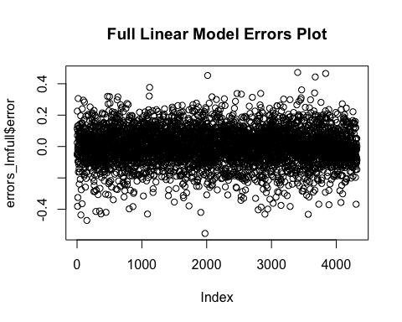

plot(varImp(lm_full_model), main="Full Linear Model Variable Importance Plot")

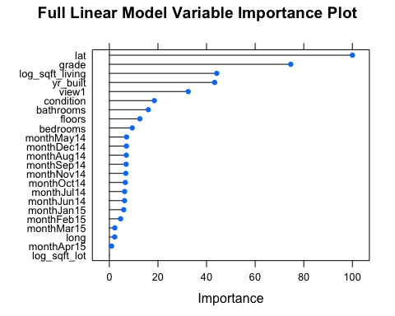

The log of sqr_lot, longitude, and all month binary variables were not found to be very important to the model. In the next linear model, I removed variables with low importance.

## Revised linear model removing variables with low importance

lm_rev_model = train(log_price ~ lat + grade + log_sqft_living + yr_built + view + condition + bathrooms +   
 floors + bedrooms,   
 data = house_train_proc,  
 method = "lm",   
 trControl = trainControl(method = "cv", number = 10))  
  
summary(lm_rev_model)

##   
## Call:  
## lm(formula = .outcome ~ ., data = dat)  
##   
## Residuals:  
## Min 1Q Median 3Q Max   
## -0.55530 -0.07199 -0.00101 0.06777 0.61424   
##   
## Coefficients:  
## Estimate Std. Error t value Pr(>|t|)   
## (Intercept) 5.6574231 0.0009081 6230.003 <2e-16 ***  
## lat 0.0810268 0.0008939 90.644 <2e-16 ***  
## grade 0.0959963 0.0014307 67.098 <2e-16 ***  
## log_sqft_living 0.0734934 0.0017318 42.437 <2e-16 ***  
## yr_built -0.0476617 0.0011703 -40.727 <2e-16 ***  
## view1 0.0912122 0.0030709 29.702 <2e-16 ***  
## condition 0.0158650 0.0009353 16.962 <2e-16 ***  
## bathrooms 0.0227593 0.0015117 15.055 <2e-16 ***  
## floors 0.0138602 0.0010739 12.907 <2e-16 ***  
## bedrooms -0.0105057 0.0011342 -9.263 <2e-16 ***  
## ---  
## Signif. codes: 0 '***' 0.001 '**' 0.01 '*' 0.05 '.' 0.1 ' ' 1  
##   
## Residual standard error: 0.1126 on 17273 degrees of freedom  
## Multiple R-squared: 0.7559, Adjusted R-squared: 0.7558   
## F-statistic: 5943 on 9 and 17273 DF, p-value: < 2.2e-16

summary(lm_rev_model$finalModel)

##   
## Call:  
## lm(formula = .outcome ~ ., data = dat)  
##   
## Residuals:  
## Min 1Q Median 3Q Max   
## -0.55530 -0.07199 -0.00101 0.06777 0.61424   
##   
## Coefficients:  
## Estimate Std. Error t value Pr(>|t|)   
## (Intercept) 5.6574231 0.0009081 6230.003 <2e-16 ***  
## lat 0.0810268 0.0008939 90.644 <2e-16 ***  
## grade 0.0959963 0.0014307 67.098 <2e-16 ***  
## log_sqft_living 0.0734934 0.0017318 42.437 <2e-16 ***  
## yr_built -0.0476617 0.0011703 -40.727 <2e-16 ***  
## view1 0.0912122 0.0030709 29.702 <2e-16 ***  
## condition 0.0158650 0.0009353 16.962 <2e-16 ***  
## bathrooms 0.0227593 0.0015117 15.055 <2e-16 ***  
## floors 0.0138602 0.0010739 12.907 <2e-16 ***  
## bedrooms -0.0105057 0.0011342 -9.263 <2e-16 ***  
## ---  
## Signif. codes: 0 '***' 0.001 '**' 0.01 '*' 0.05 '.' 0.1 ' ' 1  
##   
## Residual standard error: 0.1126 on 17273 degrees of freedom  
## Multiple R-squared: 0.7559, Adjusted R-squared: 0.7558   
## F-statistic: 5943 on 9 and 17273 DF, p-value: < 2.2e-16

predictions_lm_rev = predict(lm_rev_model, newdata = house_test_proc)  
  
postResample(pred = predictions_lm_rev, obs = house_test_proc$log_price)

## RMSE Rsquared MAE   
## 0.11362620 0.75912992 0.08702566

errors_lm_rev = data.frame(pred = predictions_lm_rev,   
 obs = house_test_proc$log_price,  
 error = predictions_lm_rev - house_test_proc$log_price)

ggplot(data = errors_lm_rev, aes(x = pred, y = obs)) +  
 geom_point() +   
 geom_abline(intercept = 0, slope = 1, color = "red") +  
 xlim(5,7) +

ylim(5,7) +

labs(title="Revised Linear Model - Predicted vs. Observed Scores")



plot(errors_lm_rev$error, main="Revised Linear Model Errors Plot")

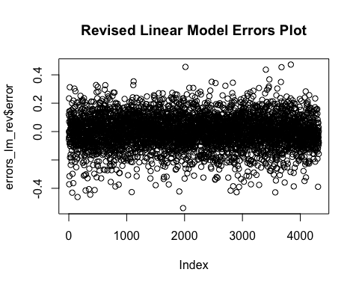

plot(varImp(lm_rev_model), main="Revised Linear Model Variable Importance Plot")

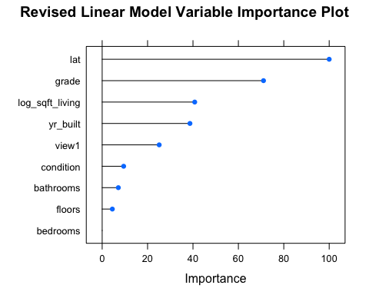

## Revised linear model again to include both variables with more importance and those included in prediction criteria.

The second model was shown to perform very similarly to the initial model, with very similar Rsquared and RMSE values. In this model, the given criteria left out of the second model due to low importance values were added.

lm_rev_model2 = train(log_price ~ lat + grade + bedrooms + log_sqft_living + bathrooms + log_sqft_lot +   
 condition + yr_built + view + floors,  
 data = house_train_proc,  
 method = "lm",   
 trControl = trainControl(method = "cv", number = 10))  
  
summary(lm_rev_model2)

##   
## Call:  
## lm(formula = .outcome ~ ., data = dat)  
##   
## Residuals:  
## Min 1Q Median 3Q Max   
## -0.55532 -0.07198 -0.00102 0.06776 0.61440   
##   
## Coefficients:  
## Estimate Std. Error t value Pr(>|t|)   
## (Intercept) 5.657e+00 9.081e-04 6229.806 <2e-16 ***  
## lat 8.102e-02 9.076e-04 89.266 <2e-16 ***  
## grade 9.600e-02 1.434e-03 66.965 <2e-16 ***  
## bedrooms -1.051e-02 1.135e-03 -9.256 <2e-16 ***  
## log_sqft_living 7.352e-02 1.824e-03 40.314 <2e-16 ***  
## bathrooms 2.275e-02 1.522e-03 14.952 <2e-16 ***  
## log_sqft_lot -4.427e-05 1.015e-03 -0.044 0.965   
## condition 1.586e-02 9.354e-04 16.960 <2e-16 ***  
## yr_built -4.766e-02 1.170e-03 -40.723 <2e-16 ***  
## view1 9.121e-02 3.071e-03 29.700 <2e-16 ***  
## floors 1.384e-02 1.144e-03 12.098 <2e-16 ***  
## ---  
## Signif. codes: 0 '***' 0.001 '**' 0.01 '*' 0.05 '.' 0.1 ' ' 1  
##   
## Residual standard error: 0.1126 on 17272 degrees of freedom  
## Multiple R-squared: 0.7559, Adjusted R-squared: 0.7558   
## F-statistic: 5348 on 10 and 17272 DF, p-value: < 2.2e-16

summary(lm_rev_model2$finalModel)

##   
## Call:  
## lm(formula = .outcome ~ ., data = dat)  
##   
## Residuals:  
## Min 1Q Median 3Q Max   
## -0.55532 -0.07198 -0.00102 0.06776 0.61440   
##   
## Coefficients:  
## Estimate Std. Error t value Pr(>|t|)   
## (Intercept) 5.657e+00 9.081e-04 6229.806 <2e-16 ***  
## lat 8.102e-02 9.076e-04 89.266 <2e-16 ***  
## grade 9.600e-02 1.434e-03 66.965 <2e-16 ***  
## bedrooms -1.051e-02 1.135e-03 -9.256 <2e-16 ***  
## log_sqft_living 7.352e-02 1.824e-03 40.314 <2e-16 ***  
## bathrooms 2.275e-02 1.522e-03 14.952 <2e-16 ***  
## log_sqft_lot -4.427e-05 1.015e-03 -0.044 0.965   
## condition 1.586e-02 9.354e-04 16.960 <2e-16 ***  
## yr_built -4.766e-02 1.170e-03 -40.723 <2e-16 ***  
## view1 9.121e-02 3.071e-03 29.700 <2e-16 ***  
## floors 1.384e-02 1.144e-03 12.098 <2e-16 ***  
## ---  
## Signif. codes: 0 '***' 0.001 '**' 0.01 '*' 0.05 '.' 0.1 ' ' 1  
##   
## Residual standard error: 0.1126 on 17272 degrees of freedom  
## Multiple R-squared: 0.7559, Adjusted R-squared: 0.7558   
## F-statistic: 5348 on 10 and 17272 DF, p-value: < 2.2e-16

predictions_lm_rev_model2 = predict(lm_rev_model2, newdata = house_test_proc)  
  
postResample(pred = predictions_lm_rev_model2, obs = house_test_proc$log_price)

## RMSE Rsquared MAE   
## 0.11362569 0.75913203 0.08702453

errors_lm_rev_model2 = data.frame(pred = predictions_lm_rev_model2,   
 obs = house_test_proc$log_price,  
 error = predictions_lm_rev_model2 - house_test_proc$log_price)

ggplot(data = errors_lm_rev_model2, aes(x = pred, y = obs)) +  
 geom_point() +   
 geom_abline(intercept = 0, slope = 1, color = "red") +  
 xlim(5,7) +

ylim(5,7) +   
 labs(title="Revised Linear Model w/Criteria - Predicted vs. Observed Scores")

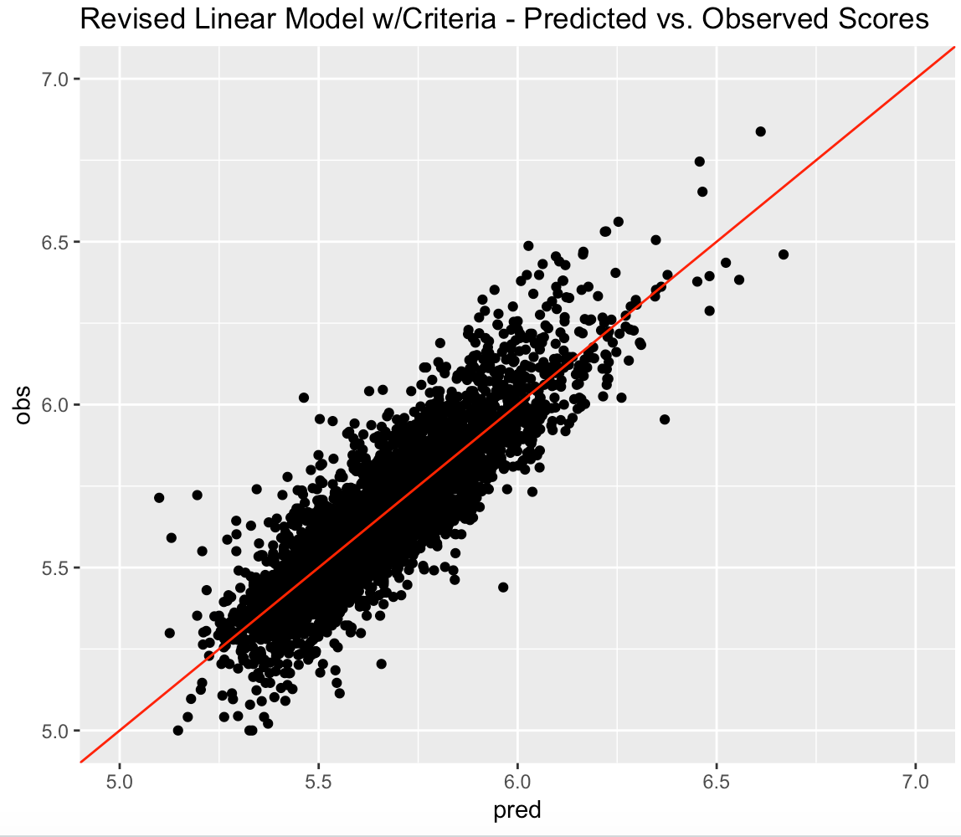

plot(errors_lm_rev_model2$error, main="Revised Linear Model w/Criteria Errors Plot")

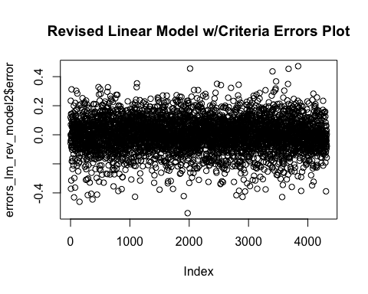

plot(varImp(lm_rev_model2, main="Revised Linear Model w/Criteria Variable Importance Plot"))

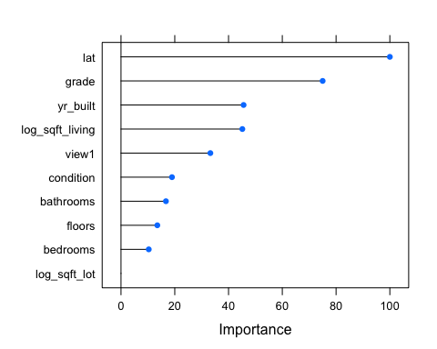

## Training a final linear model including only the variables in the criteria.

I wanted to examine the performance of a model if only the given criteria were included.

lm_fin_model = train(log_price ~ bedrooms + bathrooms + log_sqft_living + log_sqft_lot + condition +  
 grade + yr_built,  
 data = house_train_proc,  
 method = "lm",   
 trControl = trainControl(method = "cv", number = 10))  
  
summary(lm_fin_model)

##   
## Call:  
## lm(formula = .outcome ~ ., data = dat)  
##   
## Residuals:  
## Min 1Q Median 3Q Max   
## -0.50808 -0.09254 0.00680 0.09049 0.70772   
##   
## Coefficients:  
## Estimate Std. Error t value Pr(>|t|)   
## (Intercept) 5.666369 0.001050 5395.440 <2e-16 ***  
## bedrooms -0.017211 0.001383 -12.442 <2e-16 ***  
## bathrooms 0.030083 0.001832 16.420 <2e-16 ***  
## log_sqft_living 0.080999 0.002223 36.438 <2e-16 ***  
## log_sqft_lot -0.019557 0.001147 -17.049 <2e-16 ***  
## condition 0.009810 0.001136 8.633 <2e-16 ***  
## grade 0.125240 0.001694 73.953 <2e-16 ***  
## yr_built -0.075361 0.001333 -56.514 <2e-16 ***  
## ---  
## Signif. codes: 0 '***' 0.001 '**' 0.01 '*' 0.05 '.' 0.1 ' ' 1  
##   
## Residual standard error: 0.1381 on 17275 degrees of freedom  
## Multiple R-squared: 0.6331, Adjusted R-squared: 0.633   
## F-statistic: 4259 on 7 and 17275 DF, p-value: < 2.2e-16

summary(lm_fin_model$finalModel)

##   
## Call:  
## lm(formula = .outcome ~ ., data = dat)  
##   
## Residuals:  
## Min 1Q Median 3Q Max   
## -0.50808 -0.09254 0.00680 0.09049 0.70772   
##   
## Coefficients:  
## Estimate Std. Error t value Pr(>|t|)   
## (Intercept) 5.666369 0.001050 5395.440 <2e-16 ***  
## bedrooms -0.017211 0.001383 -12.442 <2e-16 ***  
## bathrooms 0.030083 0.001832 16.420 <2e-16 ***  
## log_sqft_living 0.080999 0.002223 36.438 <2e-16 ***  
## log_sqft_lot -0.019557 0.001147 -17.049 <2e-16 ***  
## condition 0.009810 0.001136 8.633 <2e-16 ***  
## grade 0.125240 0.001694 73.953 <2e-16 ***  
## yr_built -0.075361 0.001333 -56.514 <2e-16 ***  
## ---  
## Signif. codes: 0 '***' 0.001 '**' 0.01 '*' 0.05 '.' 0.1 ' ' 1  
##   
## Residual standard error: 0.1381 on 17275 degrees of freedom  
## Multiple R-squared: 0.6331, Adjusted R-squared: 0.633   
## F-statistic: 4259 on 7 and 17275 DF, p-value: < 2.2e-16

predictions_lm_fin_model = predict(lm_fin_model, newdata = house_test_proc)  
  
postResample(pred = predictions_lm_fin_model, obs = house_test_proc$log_price)

## RMSE Rsquared MAE   
## 0.1366862 0.6514529 0.1074644

errors_lm_fin_model = data.frame(pred = predictions_lm_fin_model,   
 obs = house_test_proc$log_price,  
 error = predictions_lm_fin_model - house_test_proc$log_price)

ggplot(data = errors_lm_fin_model, aes(x = pred, y = obs)) +  
 geom_point() +   
 geom_abline(intercept = 0, slope = 1, color = "red") +  
 xlim(5,7) +

ylim(5,7) +   
 labs(title="Final Linear Model w/Criteria Only - Predicted vs. Observed Scores")

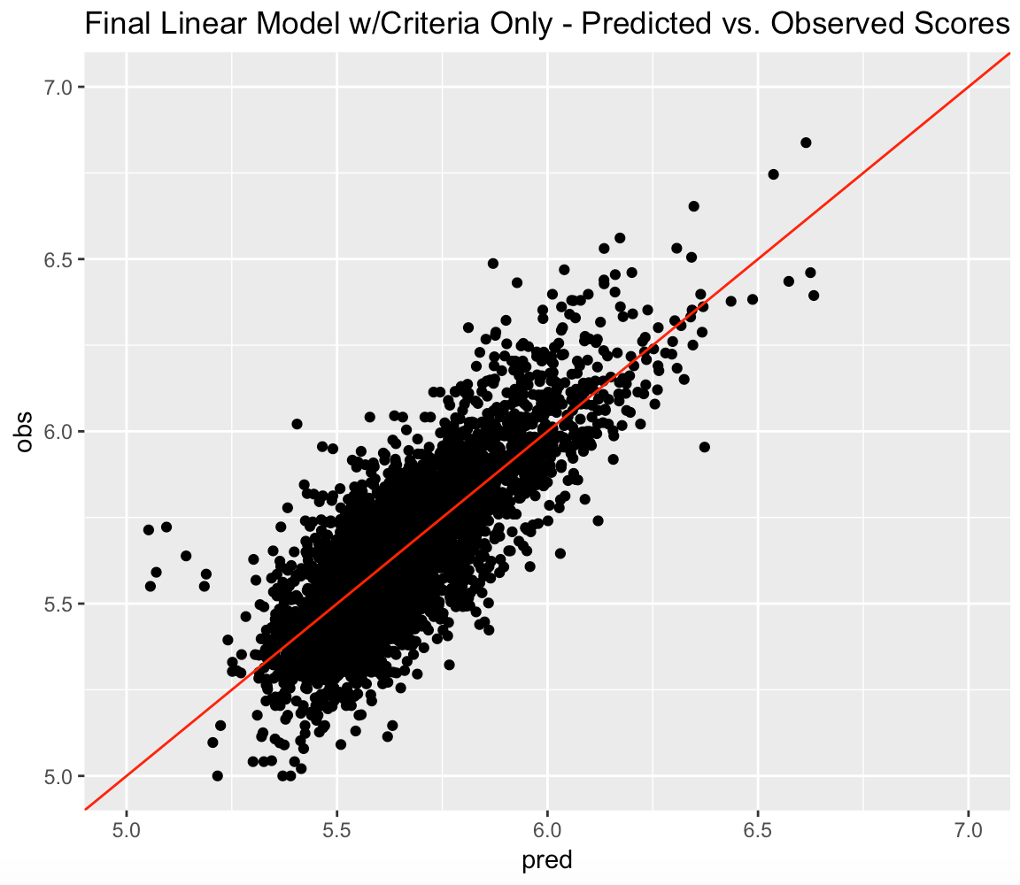

plot(errors_lm_fin_model$error, main="Final Linear Model w/Criteria Only Errors Plot")

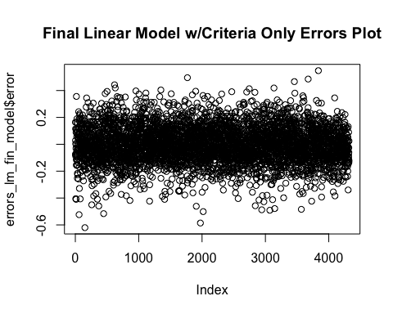

plot(varImp(lm_fin_model, main="Final Linear Model w/Criteria Only Variable Importance Plot"))

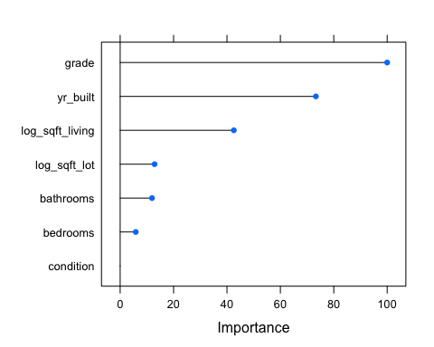

## Comparing the four linear models across their RMSE, Rsquared and MAE scores to determine best predictive model.

results = resamples(list(Full_model = lm_full_model, Importance_model = lm_rev_model,  
 Revised_model = lm_rev_model2, Criteria_model = lm_fin_model))  
  
dotplot(results, main="Linear Model Comparison")

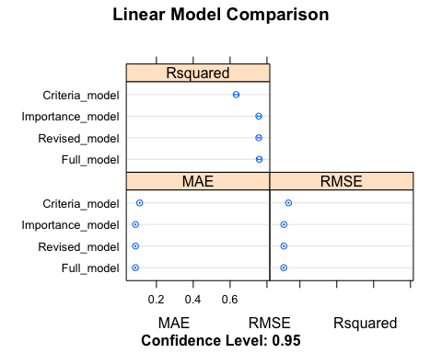

It appears the model containing only the variables representing the given prediction criteria performed the worst of the four linear models, with the other three models performing extremely similarly, each at .76 Rsquared and .112 RMSE. ‘Lat,’ ‘grade,’ ‘yr_built,’ and ‘sqft_living,’ were the most important in contributing to the prediction in the models, while ‘long,’ ‘sqft_lot,’ and all of the binary ‘month’ variables were of least importance. Although the month variables reached significant at the *p* value in the full model, they did not contribute much to the prediction. Perhaps with added data (and thereby, added time periods), more importance would be placed on a time variable.

More generally, the linear trends of the predicted vs. observed scores plots and homoscedasticity of the error plots were an encouraging sign of good model performance.

**Random Forest Model**

Here I constructed a Random Forest model based on the variables used in the revised linear model (third model) which included all of the variables most important to the model plus any other given criteria variables.

train_control<- trainControl(method="cv", number=3, savePredictions = TRUE)  
rf_model <- train(log_price ~ lat + grade + bedrooms + log_sqft_living + bathrooms + log_sqft_lot +   
 condition + yr_built + view + floors,   
 data=house_train_proc, trControl=train_control, method="rf")  
  
rf_model

## Random Forest   
##   
## 17283 samples  
## 10 predictor  
##   
## No pre-processing  
## Resampling: Cross-Validated (3 fold)   
## Summary of sample sizes: 11522, 11522, 11522   
## Resampling results across tuning parameters:  
##   
## mtry RMSE Rsquared MAE   
## 2 0.08816902 0.8533232 0.06338609  
## 6 0.08599636 0.8577327 0.06146333  
## 10 0.08718717 0.8536971 0.06242746  
##   
## RMSE was used to select the optimal model using the smallest value.  
## The final value used for the model was mtry = 6.

predictions_rf = predict(rf_model, newdata = house_test_proc)  
  
postResample(pred = predictions_rf, obs = house_test_proc$log_price)

## RMSE Rsquared MAE   
## 0.08621680 0.86151456 0.06062975

errors_rf= data.frame(pred = predictions_rf,   
 obs = house_test_proc$log_price,  
 error = predictions_rf - house_test_proc$log_price)

plot(errors_rf$error, main="RF Model Errors Plot")

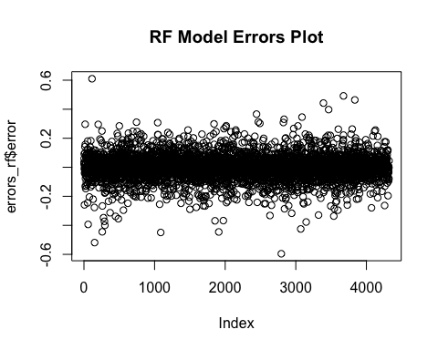

plot(rf_model, main="Plot of RF model")

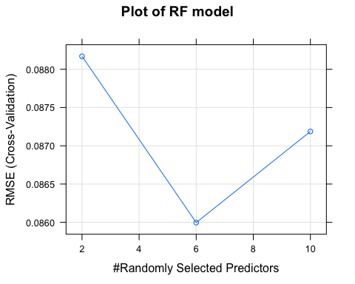

plot(rf_model$finalModel, main="Plot of Final RF model")

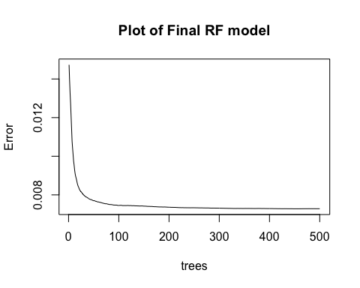

We have seen here, already, that the random forest model is performing much better than any of the linear models. After applying the model to the test set, the model had an Rsquared value of .862 and an RMSE of .086. The RF model plot also showed that it performed best if 6 predictors were used.

In the second Random Forest model, I have included only the given prediction criteria.

train_control<- trainControl(method="cv", number=3, savePredictions = TRUE)  
rf_model_crit<- train(log_price ~ bedrooms + bathrooms + log_sqft_living + log_sqft_lot + condition +  
 grade + yr_built,  
 data=house_train_proc, trControl=train_control, method="rf")  
rf_model_crit

## Random Forest   
##   
## 17283 samples  
## 7 predictor  
##   
## No pre-processing  
## Resampling: Cross-Validated (3 fold)   
## Summary of sample sizes: 11523, 11522, 11521   
## Resampling results across tuning parameters:  
##   
## mtry RMSE Rsquared MAE   
## 2 0.1296027 0.6767707 0.1011162  
## 4 0.1307077 0.6711598 0.1014624  
## 7 0.1320982 0.6646112 0.1024383  
##   
## RMSE was used to select the optimal model using the smallest value.  
## The final value used for the model was mtry = 2.

predictions_rf_crit = predict(rf_model_crit, newdata = house_test_proc)  
  
postResample(pred = predictions_rf_crit, obs = house_test_proc$log_price)

## RMSE Rsquared MAE   
## 0.12854073 0.69256079 0.09965217

errors_rf_crit= data.frame(pred = predictions_rf_crit,   
 obs = house_test_proc$log_price,  
 error = predictions_rf_crit - house_test_proc$log_price)

plot(errors_rf_crit$error, main="RF Criteria Model Errors Plot")

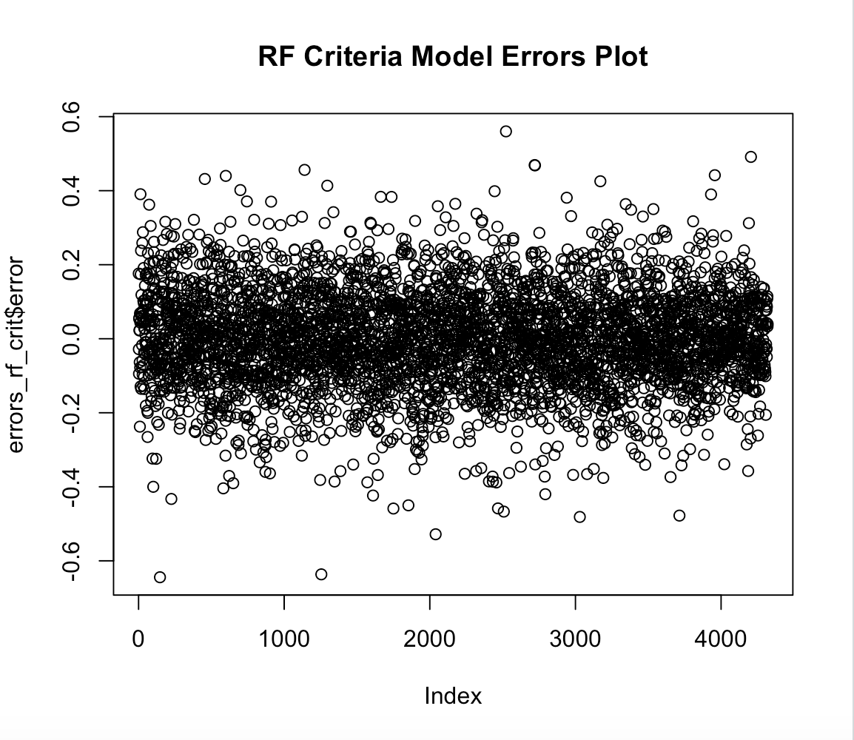

plot(rf_model_crit, main="Plot of RF Criteria Model")

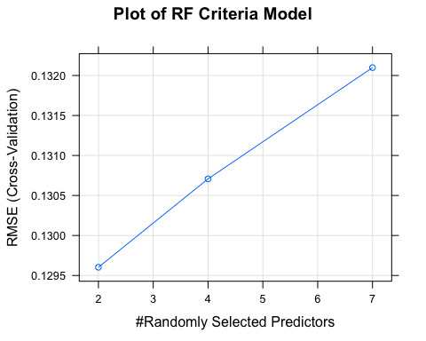

plot(rf_model_crit$finalModel, main="Plot of Final RF Criteria Model")

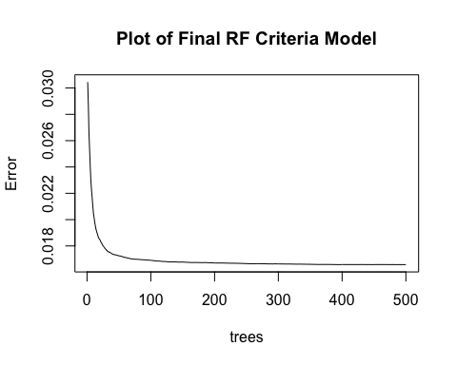

Here the second model appears to show performance would have been best with only 2 of the predictors used.

# Comparing the RF model performance metrics.

RF_model_comp <- postResample(pred = predictions_rf, obs = house_test_proc$log_price)  
RF_rev_comp <- postResample(pred = predictions_rf_crit, obs = house_test_proc$log_price)  
  
RF_model_comp

## RMSE Rsquared MAE   
## 0.08621680 0.86151456 0.06062975

RF_rev_comp

## RMSE Rsquared MAE   
## 0.12854073 0.69256079 0.09965217

As the metrics show, building a model using only the given criteria resulted in a poorer performing model. Including additional criteria, such as ‘lat,’ boosted the model’s performance. This was also observed in the linear models. The best performing model to use in predicting home price is clearly the initial RF model that included the given criteria along with the criteria previously seen to be more important to model performance.

## Predicting home price with given criteria.

First, the revised RF model was used in order to predict only the criteria given: 4 bedrooms, 3 bath, 4000 sqft living area, a 5000 sqft lot, a condition rating of 5 (highest), a grade rating of 7 (up to 13), and earliest year of build, 2004 (highest 2015).

In this iteration of predict, the revised RF model predicted a house with a ‘grade’ of 7 and built in 2004 to cost **$586,542.40**. The prediction for the upper end was **$1,672,579** for a ‘grade’ of 13 and a build year of 2015.

house_predict <- house_model  
  
to_predict <- house_predict[0,]  
to_predict[1,]$bedrooms <- 4  
to_predict[1,]$bathrooms <- 3  
to_predict[1,]$log_sqft_living <- log10(4000)  
to_predict[1,]$log_sqft_lot <- log10(5000)  
to_predict[1,]$condition <- 5  
to_predict[1,]$grade <- 7  
to_predict[1,]$yr_built <- 2004  
  
glimpse(to_predict)

## Observations: 1  
## Variables: 26  
## $ bedrooms <dbl> 4  
## $ bathrooms <dbl> 3  
## $ floors <dbl> NA  
## $ view <fct> NA  
## $ condition <dbl> 5  
## $ grade <dbl> 7  
## $ yr_built <dbl> 2004  
## $ yr_renovated <dbl> NA  
## $ lat <dbl> NA  
## $ long <dbl> NA  
## $ log_price <dbl> NA  
## $ log_sqft_living <dbl> 3.60206  
## $ log_sqft_lot <dbl> 3.69897  
## $ monthMay14 <dbl> NA  
## $ monthJun14 <dbl> NA  
## $ monthJul14 <dbl> NA  
## $ monthAug14 <dbl> NA  
## $ monthSep14 <dbl> NA  
## $ monthOct14 <dbl> NA  
## $ monthNov14 <dbl> NA  
## $ monthDec14 <dbl> NA  
## $ monthJan15 <dbl> NA  
## $ monthFeb15 <dbl> NA  
## $ monthMar15 <dbl> NA  
## $ monthApr15 <dbl> NA  
## $ monthMay15 <dbl> NA

pred_process_steps <- preProcess(select(house_predict, bedrooms, bathrooms, log_sqft_living, log_sqft_lot,  
 condition, grade, yr_built),   
 method=c("center", "scale", "nzv"))  
  
to_predict <- predict(pred_process_steps, newdata = to_predict)  
  
#str function to view dataset var data types  
View(to_predict)  
str(to_predict)

## 'data.frame': 1 obs. of 26 variables:  
## $ bedrooms : num 0.677  
## $ bathrooms : num 1.15  
## $ floors : num NA  
## $ view : Factor w/ 2 levels "0","1": NA  
## $ condition : num 2.44  
## $ grade : num -0.56  
## $ yr_built : num 1.12  
## $ yr_renovated : num NA  
## $ lat : num NA  
## $ long : num NA  
## $ log_price : num NA  
## $ log_sqft_living: num 1.75  
## $ log_sqft_lot : num -0.524  
## $ monthMay14 : num NA  
## $ monthJun14 : num NA  
## $ monthJul14 : num NA  
## $ monthAug14 : num NA  
## $ monthSep14 : num NA  
## $ monthOct14 : num NA  
## $ monthNov14 : num NA  
## $ monthDec14 : num NA  
## $ monthJan15 : num NA  
## $ monthFeb15 : num NA  
## $ monthMar15 : num NA  
## $ monthApr15 : num NA  
## $ monthMay15 : num NA

antilog<-function(lx,base) {  
 lbx<-lx/log(exp(1),base=base)   
 result<-exp(lbx)   
 result   
 }   
  
prediction <- predict(rf_model_crit, newdata = to_predict)  
  
antilog(prediction,10)

## NA   
## 586542.4

house_predict <- house_model  
  
to_predict <- house_predict[0,]  
to_predict[1,]$bedrooms <- 4  
to_predict[1,]$bathrooms <- 3  
to_predict[1,]$log_sqft_living <- log10(4000)  
to_predict[1,]$log_sqft_lot <- log10(5000)  
to_predict[1,]$condition <- 5  
to_predict[1,]$grade <- 13  
to_predict[1,]$yr_built <- 2015  
  
glimpse(to_predict)

## Observations: 1  
## Variables: 26  
## $ bedrooms <dbl> 4  
## $ bathrooms <dbl> 3  
## $ floors <dbl> NA  
## $ view <fct> NA  
## $ condition <dbl> 5  
## $ grade <dbl> 13  
## $ yr_built <dbl> 2015  
## $ yr_renovated <dbl> NA  
## $ lat <dbl> NA  
## $ long <dbl> NA  
## $ log_price <dbl> NA  
## $ log_sqft_living <dbl> 3.60206  
## $ log_sqft_lot <dbl> 3.69897  
## $ monthMay14 <dbl> NA  
## $ monthJun14 <dbl> NA  
## $ monthJul14 <dbl> NA  
## $ monthAug14 <dbl> NA  
## $ monthSep14 <dbl> NA  
## $ monthOct14 <dbl> NA  
## $ monthNov14 <dbl> NA  
## $ monthDec14 <dbl> NA  
## $ monthJan15 <dbl> NA  
## $ monthFeb15 <dbl> NA  
## $ monthMar15 <dbl> NA  
## $ monthApr15 <dbl> NA  
## $ monthMay15 <dbl> NA

pred_process_steps <- preProcess(select(house_predict, bedrooms, bathrooms, log_sqft_living, log_sqft_lot,  
 condition, grade, yr_built),   
 method=c("center", "scale", "nzv"))  
  
to_predict <- predict(pred_process_steps, newdata = to_predict)  
  
#str function to view dataset var data types  
View(to_predict)  
str(to_predict)

## 'data.frame': 1 obs. of 26 variables:  
## $ bedrooms : num 0.677  
## $ bathrooms : num 1.15  
## $ floors : num NA  
## $ view : Factor w/ 2 levels "0","1": NA  
## $ condition : num 2.44  
## $ grade : num 4.55  
## $ yr_built : num 1.5  
## $ yr_renovated : num NA  
## $ lat : num NA  
## $ long : num NA  
## $ log_price : num NA  
## $ log_sqft_living: num 1.75  
## $ log_sqft_lot : num -0.524  
## $ monthMay14 : num NA  
## $ monthJun14 : num NA  
## $ monthJul14 : num NA  
## $ monthAug14 : num NA  
## $ monthSep14 : num NA  
## $ monthOct14 : num NA  
## $ monthNov14 : num NA  
## $ monthDec14 : num NA  
## $ monthJan15 : num NA  
## $ monthFeb15 : num NA  
## $ monthMar15 : num NA  
## $ monthApr15 : num NA  
## $ monthMay15 : num NA

antilog<-function(lx,base) {  
 lbx<-lx/log(exp(1),base=base)   
 result<-exp(lbx)   
 result   
 }   
  
prediction <- predict(rf_model_crit, newdata = to_predict)  
  
antilog(prediction,10)

## NA   
## 1672579

# 

# Prediction with given criteria plus other variables shown to have importance in the best performing model(s).

In this iteration, using the best performing model, the initial RF model, the additional important criteria (‘view’, ‘lat,’ ‘floors’) were assigned values to make a prediction. This resulted in a home price at the lower end of acceptable ‘grade’ (7) and ‘yr_built’ (2004) to be **$637,482.60**. The home price at the ‘grade’ and ‘yr_built’ at the high end was **$1,506,698**.

house_predict <- house_model  
  
to_predict <- house_predict[0,]  
to_predict[1,]$bedrooms <- 4  
to_predict[1,]$bathrooms <- 3  
to_predict[1,]$log_sqft_living <- log10(4000)  
to_predict[1,]$log_sqft_lot <- log10(5000)  
to_predict[1,]$condition <- 5  
to_predict[1,]$grade <- 7  
to_predict[1,]$yr_built <- 2004  
to_predict[1,]$lat <- 47.5667  
to_predict[1,]$view <- 0  
to_predict[1,]$floors <- 2  
  
glimpse(to_predict)

## Observations: 1  
## Variables: 26  
## $ bedrooms <dbl> 4  
## $ bathrooms <dbl> 3  
## $ floors <dbl> 2  
## $ view <fct> 0  
## $ condition <dbl> 5  
## $ grade <dbl> 13  
## $ yr_built <dbl> 2015  
## $ yr_renovated <dbl> NA  
## $ lat <dbl> 47.5667  
## $ long <dbl> NA  
## $ log_price <dbl> NA  
## $ log_sqft_living <dbl> 3.60206  
## $ log_sqft_lot <dbl> 3.69897  
## $ monthMay14 <dbl> NA  
## $ monthJun14 <dbl> NA  
## $ monthJul14 <dbl> NA  
## $ monthAug14 <dbl> NA  
## $ monthSep14 <dbl> NA  
## $ monthOct14 <dbl> NA  
## $ monthNov14 <dbl> NA  
## $ monthDec14 <dbl> NA  
## $ monthJan15 <dbl> NA  
## $ monthFeb15 <dbl> NA  
## $ monthMar15 <dbl> NA  
## $ monthApr15 <dbl> NA  
## $ monthMay15 <dbl> NA

pred_process_steps <- preProcess(select(house_predict, lat, grade, bedrooms, log_sqft_living, bathrooms,   
 log_sqft_lot, condition, yr_built, view, floors),   
 method=c("center", "scale", "nzv"))  
  
to_predict <- predict(pred_process_steps, newdata = to_predict)  
  
#str function to view dataset var data types  
View(to_predict)  
str(to_predict)

## 'data.frame': 1 obs. of 26 variables:  
## $ bedrooms : num 0.677  
## $ bathrooms : num 1.15  
## $ floors : num 0.937  
## $ view : Factor w/ 2 levels "0","1": 1  
## $ condition : num 2.44  
## $ grade : num 4.55  
## $ yr_built : num 1.5  
## $ yr_renovated : num NA  
## $ lat : num 0.0478  
## $ long : num NA  
## $ log_price : num NA  
## $ log_sqft_living: num 1.75  
## $ log_sqft_lot : num -0.524  
## $ monthMay14 : num NA  
## $ monthJun14 : num NA  
## $ monthJul14 : num NA  
## $ monthAug14 : num NA  
## $ monthSep14 : num NA  
## $ monthOct14 : num NA  
## $ monthNov14 : num NA  
## $ monthDec14 : num NA  
## $ monthJan15 : num NA  
## $ monthFeb15 : num NA  
## $ monthMar15 : num NA  
## $ monthApr15 : num NA  
## $ monthMay15 : num NA

antilog<-function(lx,base) {  
 lbx<-lx/log(exp(1),base=base)   
 result<-exp(lbx)   
 result   
 }   
  
prediction <- predict(rf_model, newdata = to_predict)  
  
antilog(prediction,10)

## NA   
## 1506698

house_predict <- house_model  
  
to_predict <- house_predict[0,]  
to_predict[1,]$bedrooms <- 4  
to_predict[1,]$bathrooms <- 3  
to_predict[1,]$log_sqft_living <- log10(4000)  
to_predict[1,]$log_sqft_lot <- log10(5000)  
to_predict[1,]$condition <- 5  
to_predict[1,]$grade <- 7  
to_predict[1,]$yr_built <- 2004  
to_predict[1,]$lat <- 47.5667  
to_predict[1,]$view <- 0  
to_predict[1,]$floors <- 2  
  
glimpse(to_predict)

## Observations: 1  
## Variables: 26  
## $ bedrooms <dbl> 4  
## $ bathrooms <dbl> 3  
## $ floors <dbl> 2  
## $ view <fct> 0  
## $ condition <dbl> 5  
## $ grade <dbl> 7  
## $ yr_built <dbl> 2004  
## $ yr_renovated <dbl> NA  
## $ lat <dbl> 47.5667  
## $ long <dbl> NA  
## $ log_price <dbl> NA  
## $ log_sqft_living <dbl> 3.60206  
## $ log_sqft_lot <dbl> 3.69897  
## $ monthMay14 <dbl> NA  
## $ monthJun14 <dbl> NA  
## $ monthJul14 <dbl> NA  
## $ monthAug14 <dbl> NA  
## $ monthSep14 <dbl> NA  
## $ monthOct14 <dbl> NA  
## $ monthNov14 <dbl> NA  
## $ monthDec14 <dbl> NA  
## $ monthJan15 <dbl> NA  
## $ monthFeb15 <dbl> NA  
## $ monthMar15 <dbl> NA  
## $ monthApr15 <dbl> NA  
## $ monthMay15 <dbl> NA

pred_process_steps <- preProcess(select(house_predict, lat, grade, bedrooms, log_sqft_living, bathrooms,   
 log_sqft_lot, condition, yr_built, view, floors),   
 method=c("center", "scale", "nzv"))  
  
to_predict <- predict(pred_process_steps, newdata = to_predict)  
  
#str function to view dataset var data types  
View(to_predict)  
str(to_predict)

## 'data.frame': 1 obs. of 26 variables:  
## $ bedrooms : num 0.677  
## $ bathrooms : num 1.15  
## $ floors : num 0.937  
## $ view : Factor w/ 2 levels "0","1": 1  
## $ condition : num 2.44  
## $ grade : num -0.56  
## $ yr_built : num 1.12  
## $ yr_renovated : num NA  
## $ lat : num 0.0478  
## $ long : num NA  
## $ log_price : num NA  
## $ log_sqft_living: num 1.75  
## $ log_sqft_lot : num -0.524  
## $ monthMay14 : num NA  
## $ monthJun14 : num NA  
## $ monthJul14 : num NA  
## $ monthAug14 : num NA  
## $ monthSep14 : num NA  
## $ monthOct14 : num NA  
## $ monthNov14 : num NA  
## $ monthDec14 : num NA  
## $ monthJan15 : num NA  
## $ monthFeb15 : num NA  
## $ monthMar15 : num NA  
## $ monthApr15 : num NA  
## $ monthMay15 : num NA

antilog<-function(lx,base) {  
 lbx<-lx/log(exp(1),base=base)   
 result<-exp(lbx)   
 result   
 }   
  
prediction <- predict(rf_model, newdata = to_predict)  
  
antilog(prediction,10)

## NA   
## 637482.6

**CONCLUSIONS/CONSIDERATIONS**

As observed thus far, the best performing model for predicting home price on this dataset was a Random Forest model using the given criteria with the addition of other observed important criteria, e.g. ‘lat,’ and ‘yr_built.’ The home’s latitude was shown to have the most importance in the linear models. As seen in the earlier mapview of home locations, the concentration of homes runs north/south in King County, so where a home falls in latitude, and thereby, proximity to downtown Seattle, would have a lot of impact on the price of a home.

Future exploration and modeling of this dataset could include a better exploration of the location and grouping by neighborhoods or zones. Additional data could be added to better explore any time trends, as is known with any market, prices and sales fluctuate over time (and due to a variety of factors). Other data could also be pulled in and joined to see if other features, such as location of schools, or a job/economic opportunity measure, etc. could be used to help determine home price.